**Declaration of GST Non-Enrollment**

**TO WHOMSOEVER IT MAY CONCERN**,

**Sub: Declaration regarding non-requirement to be registered and/or not applicable under the Central / State/ UT/ Integrated Goods and Services Tax Act, 2017**

I/We Pramod Prakash Nanarkar ,(Name of the Company / Proprietor / Karta / Authorized Signatory), being __Founder of Pramod Nanarkar____ (Designation) of ___ With AJSPN7438C(Legal Name as per PAN) do hereby state that I/We am/are not liable to registration under the provisions of Goods and Service Tax Act as (please 🗹 and fill below for the relevant reason)

* I/We deal in to the category of goods or services plumbing work (Nature of goods / services) which are exempted under the Goods and Service Tax Act, 2017
* I/We have the turnover below the taxable limit as specified under the Goods and Services Tax Act, 2017
* I/We are yet to register ourselves under the Goods and Service Tax Act, 2017

I/We declare that as soon as our value of turnover exceeds Rs. 20 Lacs or during any financial year I/we decide or require or become liable to register under the GST, I/we undertake to provide all the requisite documents and information to you. I/We shall get ourselves registered with the Goods and Services Tax department and give our GSTN to your company.

I/We request you to consider this communication as a declaration for not requiring to be registered under the Goods and Service Tax Act, 2017.

I/We hereby also confirm that _Pramod Prakash Nanarkar (Name of the service recipient) shall not be liable for any loss accrued to me/us, due to any registration default with the GST.

Signed …... 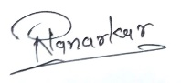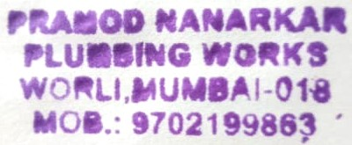

Date …19th Aug 2024 (Company Seal)

**\* Printed on company letter head**

***\** Hand written declaration is not acceptable**