**Sub : 1 HP Single Phase Water Pump**

Sir

Please check below

# Crompton CHAMP PLUS, Residential Water Pump.

# Self Priming Regenerative 1 HP Single Phase.

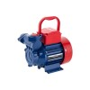

WITH REGARDS,

1. A. ELECTRICAL SOLUTIONS
2. 9930211622 / 9930907674