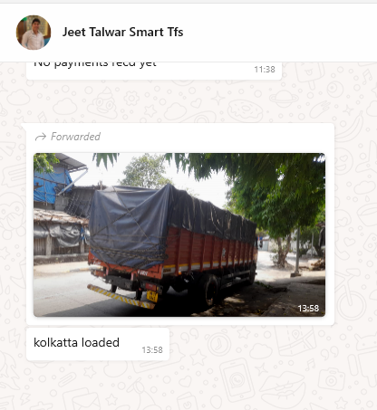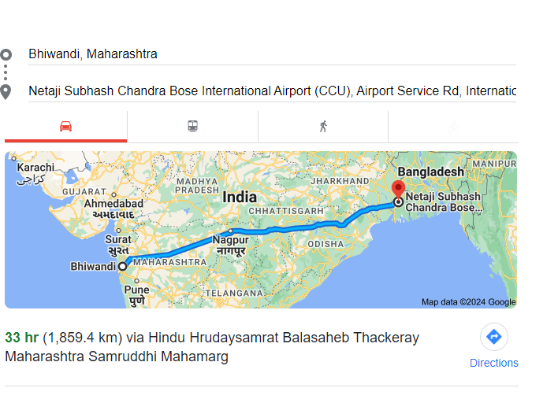
Material of Full truck load is being shifted from Bhiwandi Warehouse to Kolkata airport through surface transport and commercial also includes unloading and shifting the material from unloading point inside of the Airport premises by the transporter , Approx surface transport distance of 1870 kms which shall take 5 days from Mumbai

