HINDUSTAN TELECOMMUNICATION
Ranjit StudioCompound DadaSaheb Phalke Rd.Dadar (E) Mumbai-14

2414 6263 , 4055 6666 , 4055 6767
Quotation

To, Date: 21st Aug ,2024

K Corp

Mumbai
Kind attn : Mr Devang Shah

Dear Sir,

With reference to our discussion, we are pleased to offer you our best prices for the same.
Sr.No | Description | Qty | Unit rate | Unit Amount (Rs.)

Option I

1 | Optoma Projector ZU516SAT-1  ( 5000 Lumens for 15’ distance projection )  With wi-fi dongle | 01 | Rs.1,89,000/- | Rs.1,89,000/-
2 | Optoma Projector ZU606T  6000 Lumens  With wi-fi dongle | 01 | Rs.2,42,000/- | Rs.2,42,000/-
3 | Optoma Projector AZU717  ( 7000 Lumens for 20’ long distance projection)  With wi-fi dongle | 01 | Rs.2,89,000/- | Rs.2,89,000/-
4 | Installation , testing and commissioning charges |  | Rs.10,000/-each | Rs.10,000/-each
Option II

1 | Epson Projector Model EB-L530U  5000 Lumens  With Wi-fi compatible | 01 | Rs.1,99,800/- | Rs.1,99,800/-
2 | Epson Projector Model EB-L630U  6000 Lumens  With Wi-fi compatible | 01 | Rs.2,44,000/- | Rs.2,44,000/-
3 | Epson Projector Model EB-L730U  7000 Lumens  With Wi-fi compatible | 01 | Rs.2,89,000/- | Rs.2,89,000/-
4 | Installation , testing and commissioning charges |  | Rs.10,000/-each | Rs.10,000/-each

Motorised Screen

1 | Motorised screen 9 X 12 size | 01 | Rs.59,800/- | Rs.59,800/-
2 | Installation & Mounting of Motorised screen | 01 | Rs.8,000/- | Rs.8,000/-

 | Motorised Projector Lift
1 | Ceiling Mount Motorised Projector lift suitable for 5000 / 6000 / 7000 lumens projector  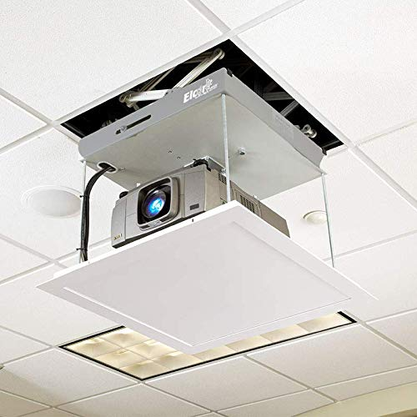 | 01 | Rs.49,800/- | Rs.49,800/-
2 | Ceiling Mount Installation , fitting & commissioning | 01 | Rs.10,000/- | Rs.10,000/-

Note : Any other accessories required would be quoted extra after site inspection.
The Request for the Date when Material is to be delivered should be informed to
us by Email
- Order Once Place Can Not Be cancelled or Returned

Terms & Conditions : -
GST :- 28% GST on Projector & 18% extra on Installation charges.
Payment :- 100% Advance .
Delivery :- Within One Week from the date of Purchase order.
Validity :- One Month

Waiting for your esteemed order & assuring you our best services at all times.
Thanking you,

Yours truly,

Rajan Malhotra
9821057679

