

|  |
| --- |
| GMR HOSPITAITY LTD. |

NOTE FOR PROCUREMENT APPROVAL

Reference No: GMR Hospitality Ltd PO/24-25/CAP/10948 KEMA GROUP SERVICES Supply of LED SCREEN for HYD FF 041 KFC Airport, Hyderabad

Subject:

Approval is requested for placing the order (CAPEX) on KEMA GROUP SERVICES “– Supply of LED SCREEN for HYD FF 041 KFC Airport, Hyderabad

Background

Budget of “HYD FF 041 KFC is approved by Board, Authority on date: 29-09-2023.

For the development of outlet at “HYD FF 041 KFC”, total approved budget is Rs. 25.82 lakh

Inclusive of taxes as per the below details:

|  |  |
| --- | --- |
| **Outlet/Brand name** | HYD FF 041 KFC |
| ***Item wise*** | **Budget with Tax** |
| Other's: IT charges | **22,176,85** |
| **Total capex budget** | **25,823,460** |

*\*total Others IT budget is of Rs 22.17 lacs out of which we are utilizing a budget of Rs.2.64 lacs for releasing* LED SCREEN

Technical Specification

Technical specifications & tender drawing have been received from project team post their review with the design consultant & same has been used as tender docket for floating RFP

Technical Assessment

BOQ has been technically validated by Projects team

Vendor Selection

We have requirement of LED SCREEN for HYD FF 041 KFC at Hyderabad. In regards to same quotes were invited from vendor, of them quotes were received from KEMA GROUP SERVICES by KEMA GROUP SERVICES were economical and therefore basis their overall negotiation, technical understanding of the LED SCREEN requirement and delivery schedule, the order is raised on KEMA GROUP SERVICES He authorized partner and we released PO with SVD Technically confirm and brand has suggested for the same LED screen.





KEMA GROUP SERVICES is evaluated and were qualified by team & KEMA GROUP SERVICES Is authorized channel partner of LED Screen already work inside the Hyderabad airport in several another projects and as per the Quality and immediate supply and installation We are going with L2 Partner because ds techwork Is not confirm to supply and installed Screen on Before time so we are selected the same vendor and execute the work .

Financial Implication:

Rs. 264162/- (Inclusive of all Taxes)

In view of above, approval is requested to place order on **KEMA GROUP SERVICES**.@ Total order value of Rs 206377/- Plus 28% GST at actuals

Payments Terms:

100% advance including GST along with PO

Contract Duration: 1 Month

PBG applicability: NA

DLP/warranty: As per term

Deviations if any:

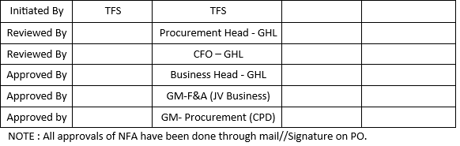

Supporting’s: Enclosed

1. Purchase Order
2. PO Approval
3. Vendor quote
4. Vendor quote
5. Email Sent to Vendor for quotation
6. Technical evaluation form

**Prepared by: Checked by:**