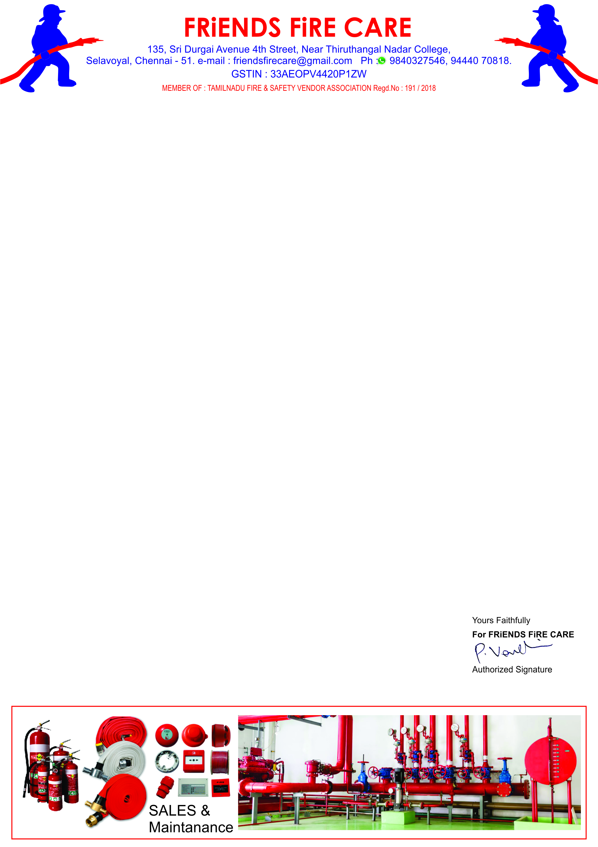

**Ref: FFC/QTN/100/ 24 -25 Date: 24.08.2024.**

**To,**

**M/S .Travel Food Services Chennai Pvt. Ltd.,**

**Chennai International Airport, Chennai-600027.**

**Dear Sir, SUB: Offer For Fire Extinguisher HP Testing, Painting, Refilling & Spares – Reg.**

**We reference to the above subject of we hereby submit our most competitive offer as under for your kind consideration.**

|  |  |  |  |  |
| --- | --- | --- | --- | --- |
| **S.NO** | **Description** | **Qty** | **Rate** | **Amount** |
| **1.** | **HP Testing, Painting, Stickering, Refilling Charges for Stored Pressure Type ABC 6 kg. Cap. Extinguishers.** | **11 No.** | **900/-** | **9,900.00** |
| **2.** | **HP Testing, Painting, Stickering, Refilling Charges for Stored Pressure Type ABC 5 kg. Cap. Extinguishers.** | **03 No.** | **750/-** | **2,250.00** |
| **3.** | **HP Testing, Painting, Stickering, Refilling Charges for Stored Pressure Type ABC 4 kg. Cap. Extinguishers.** | **11 No.** | **750/-** | **8,250.00** |
| **4.** | **HP Testing, Painting, Stickering, Refilling Charges for**  **CO2 - 2 kg. Capacity Fire Extinguishers.** | **03 No.** | **1250/-** | **3,750.00** |
| **5.** | **HP Testing, Painting, Stickering, Refilling Charges for**  **CO2 - 4.5 kg. Capacity Fire Extinguishers.** | **02 No.** | **1350/-** | **2,700.00** |
| **6.** | **Painting, Stickering, Refilling Charges for CO2 - 2 kg. Capacity Fire Extinguishers.** | **01 No.** | **650/-** | **650.00** |
| **7.** | **ABC- 4kg. Bottom Damage (So Unfilled)Transportation Charges** | **01 No.** | **250/-** | **250.00** |
| **8.** | **Supply of Discharge Hose For ABC Fire Extinguisher.** | **05 No.** | **150/-** | **750.00** |
| **9.** | **Supply of Hose holding clamp For ABC Fire Extinguisher.** | **15 No.** | **50/-** | **750.00** |
| **10.** | **Supply of Bend Pipe with Horn for CO2 - 2 kg. Ext.** | **01 No.** | **150/-** | **150.00** |
| **11.** | **Supply of Discharge Hose with Horn for CO2 - 4.5 kg. Ext.** | **01 No.** | **350/-** | **350.00** |
|  | **Sub Total** | | | **29,750.00** |
|  | **GST 18 %** | | | **5,355.00** |
|  | **Grand Total** | | | **35,105.00** |

* **ABC – 4kg Capacity. Fire Extinguisher 1no. Bottom Damage. So Unfilled.**

**General Terms**

1. **Validity : 30 days.**
2. **Price : All inclusive ( Transportation To & Fro )**
3. **Payment : 100 % Along with work order.**
4. **Work Completion : 5 to 7 days.**
5. **Warranty : Sl. No. : 1 to 5 - 3 Years & Sl. No. : 6 - 2 Years.**

**We thank you for your confidence on us and we assure you that we will provide our prompt and best services at all times.**