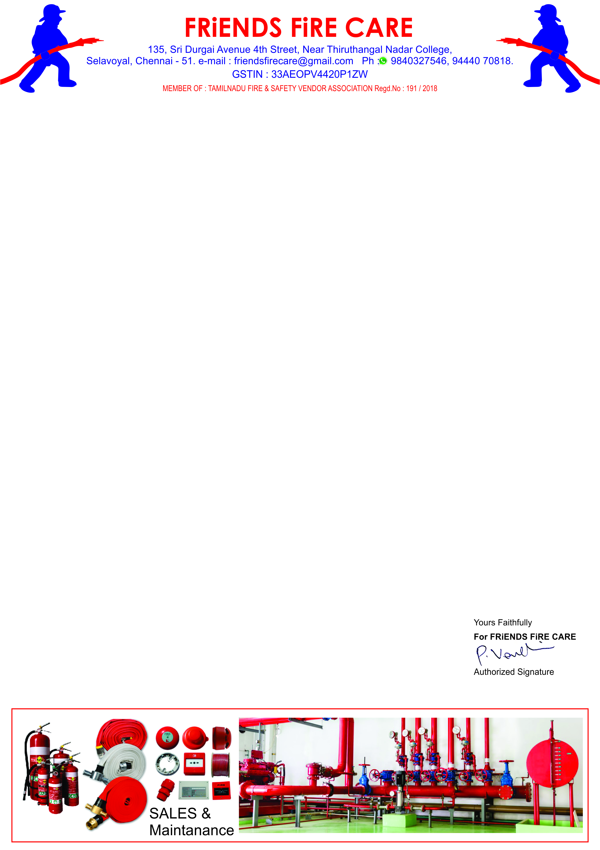

**Ref: FFC/QTN/123/ 24 -25**

**Date: 14.10.2024.**

**To,**

**M/S .Travel Food Services Pvt. Ltd.,**

**Chennai International Airport, Chennai- 600 027.**

**Dear Sir,**

**SUB: Offer For Fire Extinguisher HP Testing, Painting, Refilling & Spares – Reg.**

**We reference to the above subject of we hereby submit our most competitive offer as under for your kind consideration.**

|  |  |  |  |  |
| --- | --- | --- | --- | --- |
| **S.NO** | **Description** | **Qty** | **Rate** | **Amount** |
| **1.** | **HP Testing, Painting, Stickering, Refilling Charges for Stored Pressure Type ABC 6 kg. Cap. Extinguishers.** | **04 No.** | **900/-** | **3,600.00** |
| **2.** | **HP Testing, Painting, Stickering, Refilling Charges for Stored Pressure Type ABC 5 kg. Cap. Extinguishers.** | **01 No.** | **750/-** | **750.00** |
| **3.** | **HP Testing, Painting, Stickering, Refilling Charges for Stored Pressure Type ABC 4 kg. Cap. Extinguishers.** | **04 No.** | **750/-** | **3,000.00** |
| **4.** | **HP Testing, Painting, Stickering, Refilling Charges for Stored Pressure Type ABC 2 kg. Cap. Extinguishers.** | **01 No.** | **600/-** | **600.00** |
| **5.** | **HP Testing, Painting, Stickering, Refilling Charges for**  **CO2 - 2 kg. Capacity Fire Extinguishers.** | **01 No.** | **1250/-** | **1,250.00** |
| **6.** | **HP Testing, Painting, Stickering, Refilling Charges for**  **CO2 - 4.5 kg. Capacity Fire Extinguishers.** | **05 No.** | **1350/-** | **6,750.00** |
| **7.** | **Supply of Hose holding clamp For ABC Fire Extinguisher.** | **10 No.** | **50/-** | **500.00** |
| **8.** | **Supply of Bend Pipe with Horn for CO2 - 2 kg. Ext.** | **01 No.** | **150/-** | **150.00** |
|  | **Sub Total** | | | **16,600.00** |
|  | **GST 18 %** | | | **2,988.00** |
|  | **Grand Total** | | | **19,588.00** |

**General Terms**

1. **Validity : 30 days.**
2. **Price : All inclusive ( Transportation To & Fro )**
3. **Payment : 100 % Along with work order.**
4. **Work Completion : 7 to 10 days.**
5. **Warranty : Sl. No. : 1 to 6 - 3 Years.**

**We thank you for your confidence on us and we assure you that we will provide our prompt and best services at all times.**