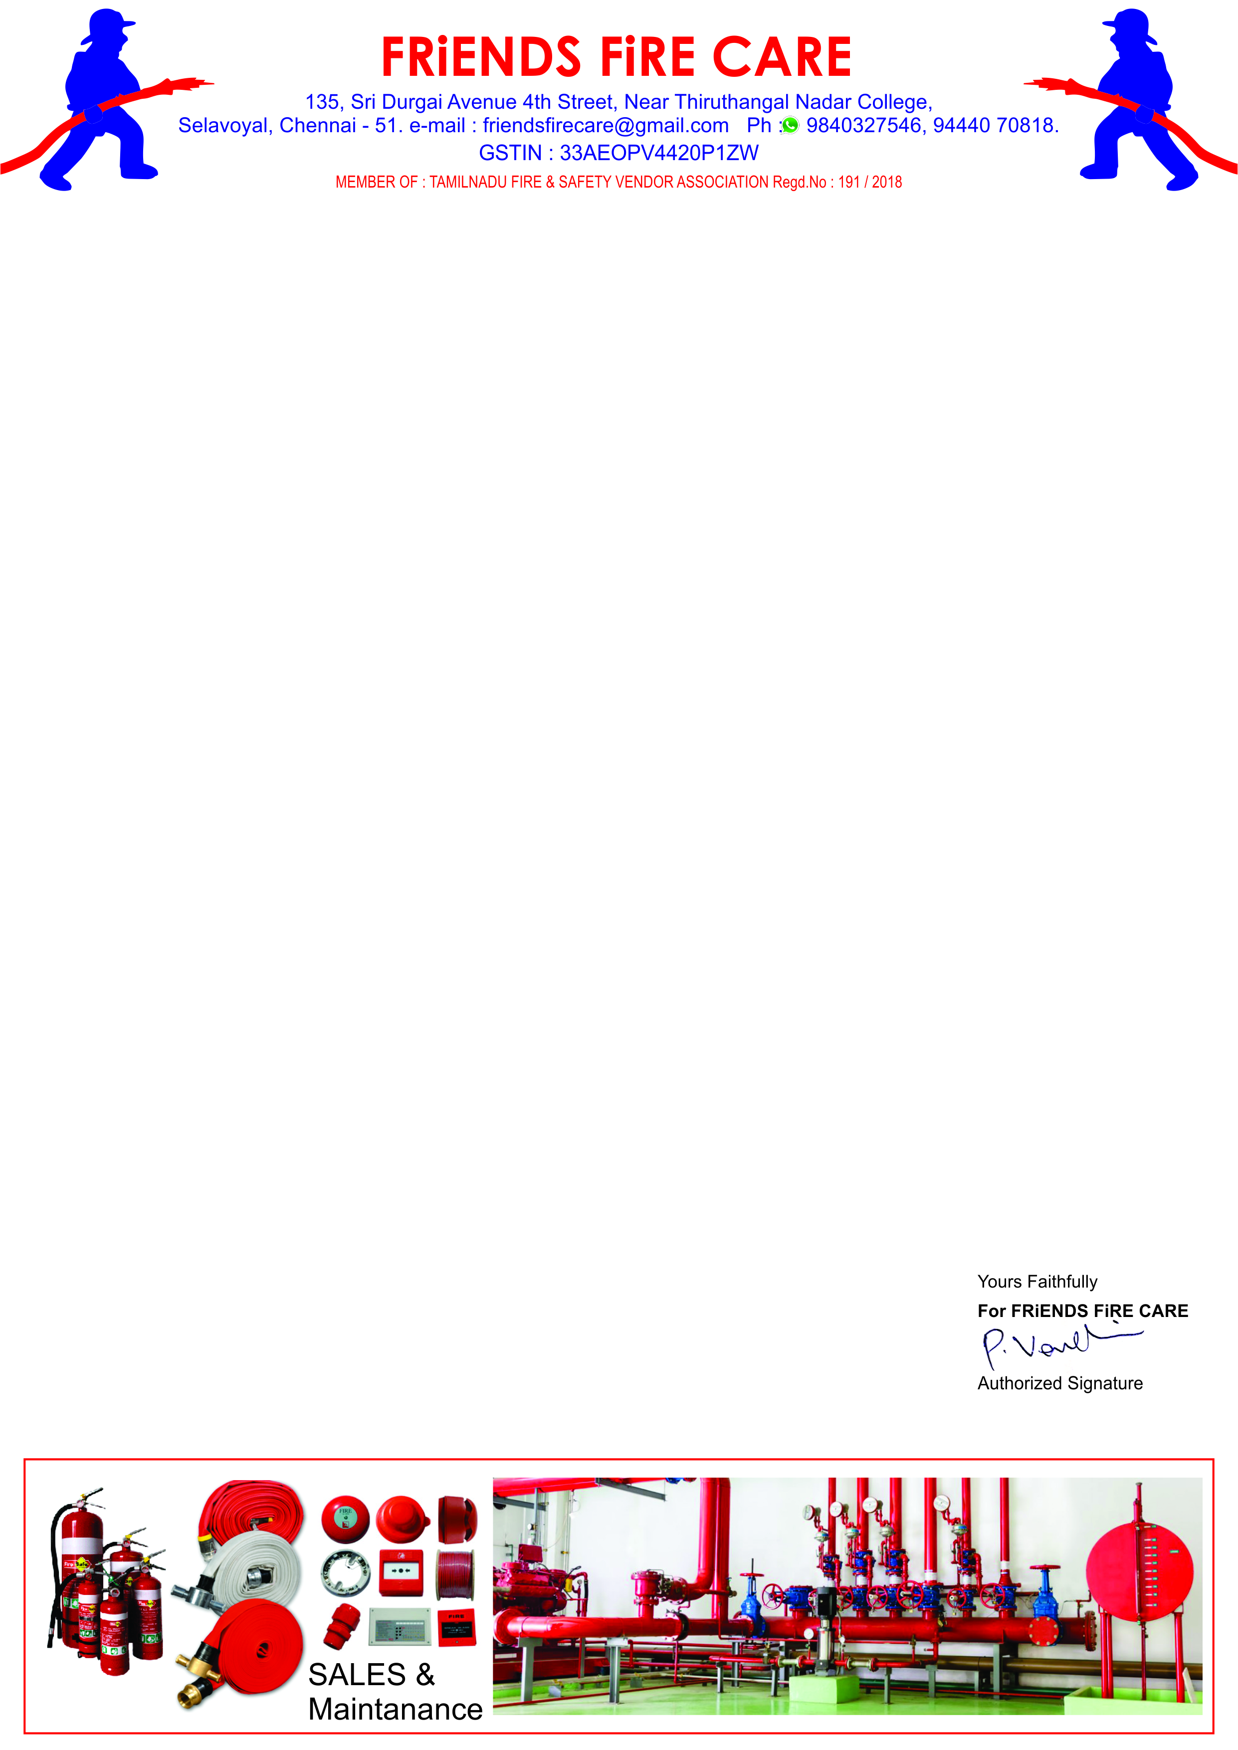

**Ref: FFC/ Qtn./065/24-25 Date: 22.06.2024.**

**To,**

**M/S .Travel Food Services Chennai Pvt. Ltd.,**

**Next to S2 Police Station,**

**Chennai International Airport,**

**Chennai-600 027.**

**Dear Sir,**

**Sub: Offer for Fire Extinguisher -Reg.**

**We reference to the above subject of we hereby submit our most competitive offer as under for your kind consideration.**

|  |  |  |  |  |
| --- | --- | --- | --- | --- |
| **S.No.** | **Particulars** | **Qty.** | **Rate** | **Amount** |
| **1.** | **Supply of ‘K’ Type - 6 Ltr. capacity Fire Extinguisher Wall Mounting Type. HSN- 8424** | **08 No.** | **4900/-** | **39,200.00** |
|  | **GST 18 %** | | | **7,056.00** |
|  | **Grand Total** | | | **46,256.00** |

**Note: Due to last Bill Payment was not Received More than 8 Months.**

**Note: If Floor Stand Required Each Rs. 500/- + GST 18 % Extra.**

**General Terms**

1. **Price : All Inclusive.**
2. **Payment : 100 % Along with PO.**

* **FRIENDS FIRE CARE, KVB -Teynampet, Chennai-18 A/C No: 1250 1150 0000 7267 IFSC :KVBL0001250**

1. **Delivery : 3 Days At Chennai Branch.**
2. **Warranty : 2 Years.**

**We thank you for your confidence on us and we assure you that we will provide our prompt and best services at all times.**