
# 62, 12th Cross,5th Main ,Wilson Garden, Bangalore-560027
QUOTATION
M/S . Travel Food Services Pvt Ltd Qtn No: SMH1001 Bangalore Date : 26-12-2023

Kind Attention.Mr . Mahadeva
Dear Sir/Madam,

We thank you very much for your enquiry. It is our great privilege to quote for your esteemed organization. We are here with quoting our lowest possible prices for your Consideration and Perusal
S.NO | Description | QTY | Product Image | Rate/Unit
01 | Shoe Shine Machine – G3  1 year warranty | 01 No | 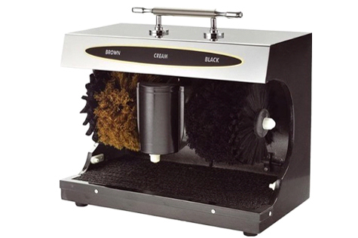 | 5800+GST
02 | Shoe Shine Machine – G5  1 year warranty | 01 No | 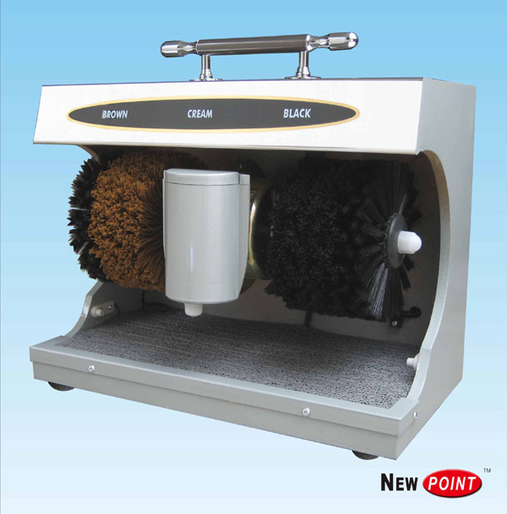 | 7800+GST
03 | Shoe Shine Machine – AXDS1  With Sole Cleaner  1 year warranty | 01 No | 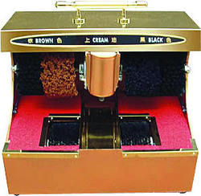 | 11500+GST

Term & Conditions :
Sales Tax : Add 18 %
Delivery : Immediately
Quotation Validity : 30 Days
Term of Payment ; Immediately From ,
Rajeshwari
S.M.HYGEINICS
97417-37777

