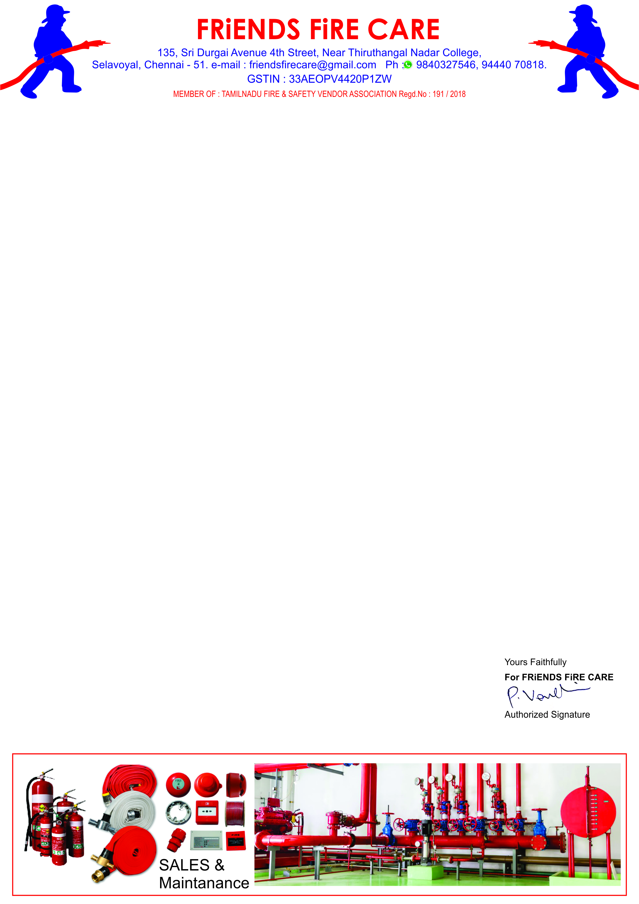

**Ref: FFC/QTN/129/ 24 -25**

**Date: 17.10.2024.**

**To,**

**M/S .Travel Food Services Pvt. Ltd.,**

**Chennai International Airport,**

**Chennai- 600 027.**

**Dear Sir,**

**SUB: Offer For Fire Alarm System Service & Spares – Reg.**

**We reference to the above subject of we hereby submit our most competitive offer as under for your kind consideration.**

|  |  |  |  |  |
| --- | --- | --- | --- | --- |
| **S.NO** | **Description** | **Qty** | **Rate** | **Amount** |
| **1.** | **Supply, Installation, Testing & Commissioning Charges for Addressable Smoke Detector With Base.** | **04 No.** | **2600/-** | **10,400.00** |
| **2.** | **Supply, Installation, Testing & Commissioning Charges for Addressable Heat Detector With Base.** | **06 No.** | **2600/-** | **15,600.00** |
| **3.** | **Fire Alarm Panel Repair & Service Charges** | **01 Job** | **3500/-** | **3,500.00** |
|  | **Sub Total** | | | **29,500.00** |
|  | **GST 18 %** | | | **5,310.00** |
|  | **Grand Total** | | | **34,810.00** |

**General Terms**

1. **Validity : 30 days.**
2. **Price : All inclusive.**
3. **Payment : 100 % Along with work order.**
4. **Work Completion : 5 Days.**

**We thank you for your confidence on us and we assure you that we will provide our prompt and best services at all times.**