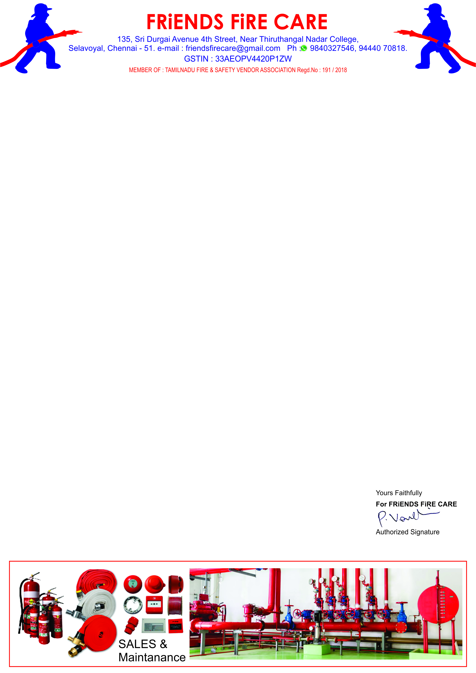

**Ref: FFC/QTN/060/ 24 -25 Date: 17.06.2024.**

**To,**

**M/S .Travel Food Services Chennai Pvt. Ltd.,**

**Next to S2 Police Station,**

**Chennai International Airport, Chennai-600027.**

**Dear Sir, SUB: Offer For Fire Extinguisher HP Testing, Painting, Refilling – Reg.**

**We reference to the above subject of we hereby submit our most competitive offer as under for your kind consideration.**

|  |  |  |  |  |
| --- | --- | --- | --- | --- |
| **S.NO** | **Description** | **Qty** | **Rate** | **Amount** |
| **1.** | **HP Testing, Painting, Stickering, Refilling Charges for Stored Pressure Type ABC 6 kg. Cap. Extinguishers.** | **06 No.** | **900/-** | **5,400.00** |
| **2.** | **HP Testing, Painting, Stickering, Refilling Charges for Stored Pressure Type ABC 2 kg. Cap. Extinguishers.** | **01 No.** | **600/-** | **600.00** |
| **3.** | **HP Testing, Painting, Stickering, Refilling Charges for**  **CO2 - 2 kg. Capacity Fire Extinguishers.** | **01 No.** | **1250/-** | **1,250.00** |
| **4.** | **HP Testing, Painting, Stickering, Refilling Charges for**  **CO2 - 4.5 kg. Capacity Fire Extinguishers.** | **04 No.** | **1350/-** | **5,400.00** |
| **5.** | **HP Testing, Painting, Stickering, Refilling Charges for Stored Pressure Type Foam - 9 ltr. Cap. Extinguisher.** | **01 No.** | **900/-** | **900.00** |
| **6.** | **Refilling Charges for Stored Pressure ‘ K ‘ - Type 6 ltr. Cap. Ext.** | **01 No.** | **2900/-** | **2,900.00** |
| **7.** | **Refilling Charges For CO2 - 22.5 kg. Capacity Extinguisher** | **01 No.** | **1900/-** | **1,900.00** |
| **8.** | **Refilling Charges For ABC - 6 kg. Capacity Extinguisher** | **04 No.** | **550/-** | **2,200.00** |
| **9.** | **Refilling Charges For ABC - 5 kg. Capacity Extinguisher** | **02 No.** | **500/-** | **1,000.00** |
| **10.** | **Refilling Charges For ABC - 4 kg. Capacity Extinguisher** | **01 No.** | **450/-** | **450.00** |
| **11.** | **Refilling Charges For ABC - 1 kg. Capacity Extinguisher** | **01 No.** | **250/-** | **250.00** |
|  | **Sub Total** | | | **22,250.00** |
|  | **GST 18 %** | | | **4,005.00** |
|  | **Grand Total** | | | **26,255.00** |

1. **Validity : 30 days.**
2. **Price : All inclusive ( Transportation To & Fro )**
3. **Payment : 100 % Along with work order.**

**(Against last Bill Payment was not Received Fully More than 8 Months)**

1. **Work Completion : 5 to 7 days.**
2. **Warranty : Sl. No. : 1 to 4 : 3 Years.**

**Sl. No. : 5 to 11 : 2 Years.**

**We thank you for your confidence on us and we assure you that we will provide our prompt and best services at all times.**