**5. Acrylic sheets with machine cut and polishing works - 8nos**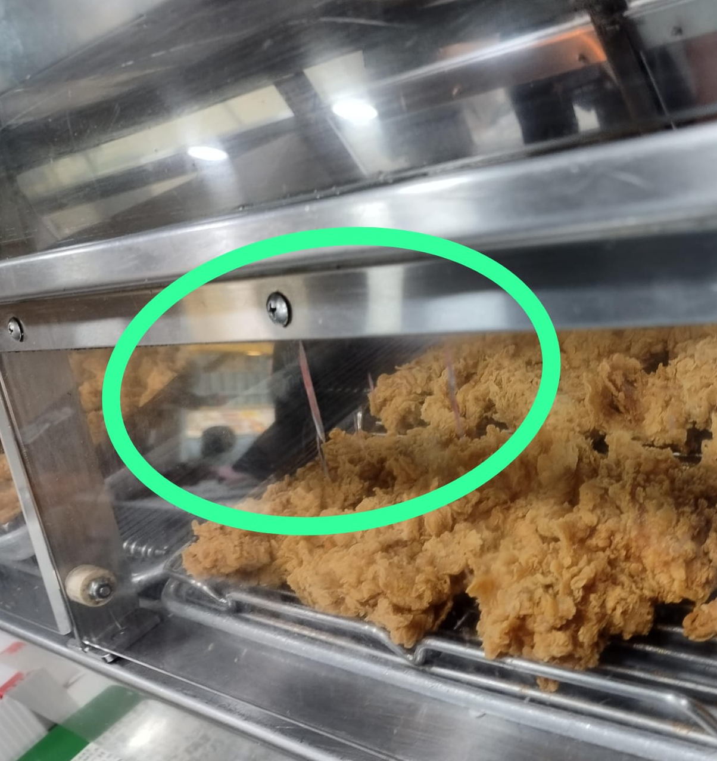

Poly carbonate sheet, Size: 195mm x 900mm x 5mm Thickness – 8nos

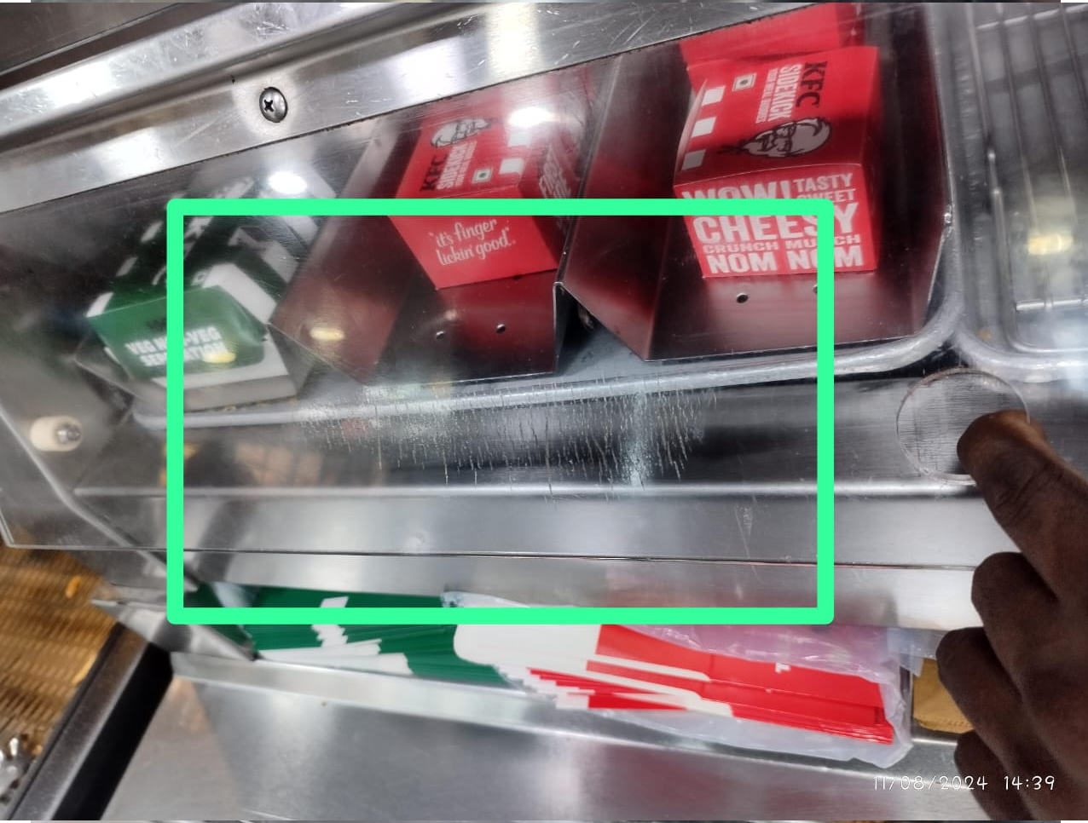

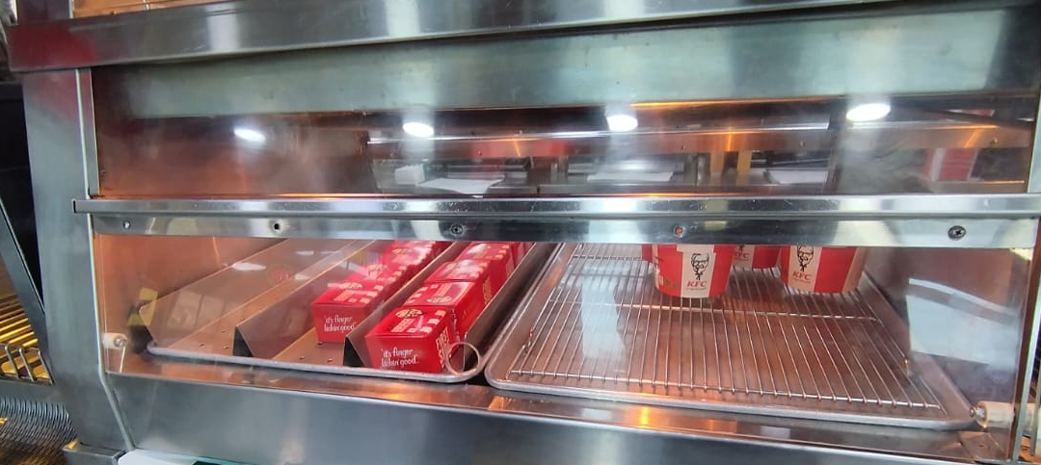

195mm

900mm

1. **5” PU grey colour wheels – 4nos**

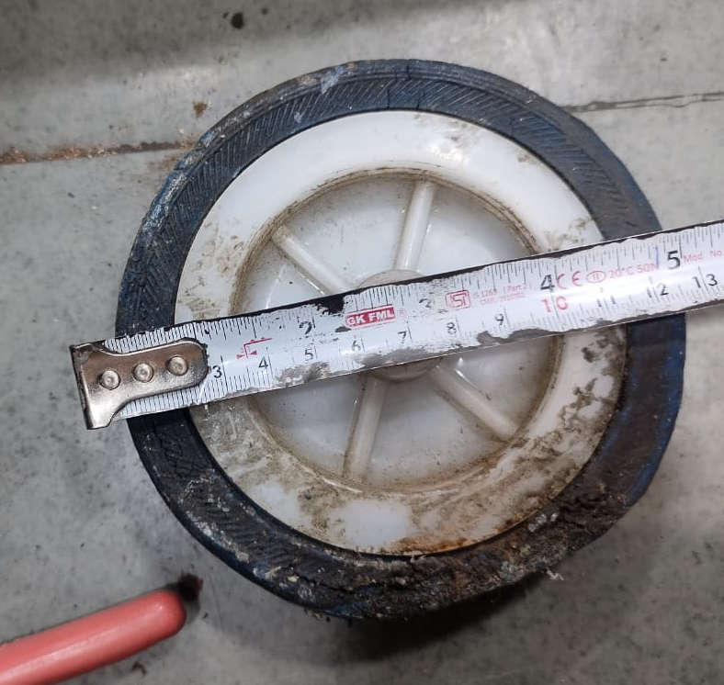

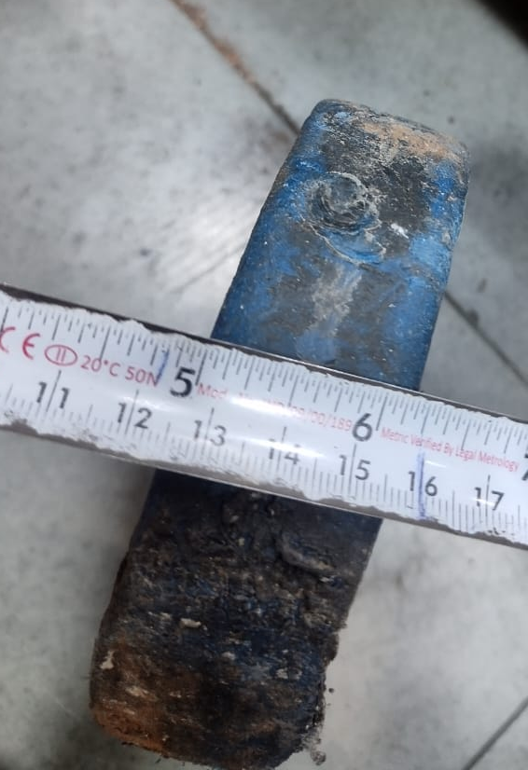

1. 1.5Nylon adjustable Bush

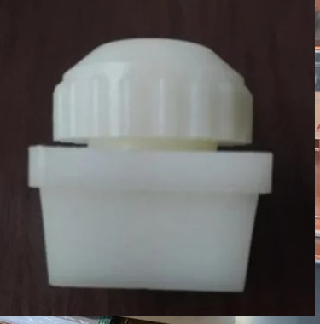

1. 1.25” Nylon Bush – 100Nos

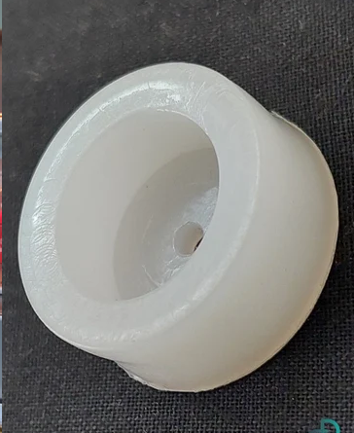

1. 1” Nylon Bush – 100Nos

