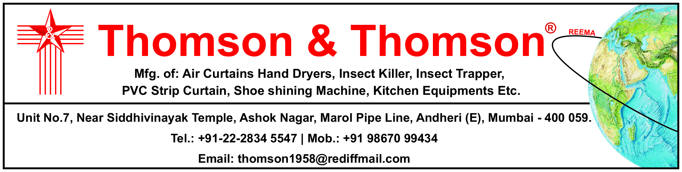Date -12 /7 /2024 Our GST No 27ATRPT3430F1ZE

To :Maintenance Naseer shaikh

Contact No: 9833561007

email:Nasser.mainteenaqnce2mumbailounge.in

We refer to the discussion regarding your requirement of Thomson & Thomson Air curtain. .Based on your requirement we suggest the below mentioned models for incorporation at your site

**THOMSON & THOMSON AIRCURTAIN**

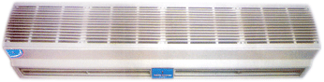

**MODEL E H V**

Body M.S powder coated

Colour Half White

Blower impeller ( Dynamic Balancing)

Moter Induction moter Continue rating 1 Phase

Two speed Motor

(Your requirement body length 3ft’ X 2 Nuts ( 9.5’’ x9.5’’ ]

price – 15500rs Per nuts

Discounted Price 12500 rsPerunit

Two Unit =25000 Rs

GST 18%extra

50% advance balance against delivery

Quotation Validity 30 Days.

**&Conditions:**

* Warranty : One Year.
* Delivery Schedule : Within 1 Week

**Manufacturer of:-**

**1. Air curtain.**

**2. Automatic Hand dryers.**

**3. P V C. Strip curtain.**

**4. Flap Door**

**5. Fly killers**

**6. Insect Trapper Machine**

**7. UV Sterilizer**

**9. Airpurifier**

**10. Auto Tap**

**11. Auto Urinal Flushing Concealed Type.**

**12. Shoe Shining Machine**

**13. Liquid Shop Dispenser (Auto & Manual)**

Thanking You,

For Thomson & Thomson.

G.THOMAS

**M obile No :9867099434**

**For more details please visit**

[**www.thomsonandthomson.in**](http://www.thomsonandthomson.in)

**Thomson & Thomson ( Bank Details )**

**Citizencredit Co-op Bank Ltd , Marol Branch , Andheri (e).**

**NEFT/RTGS.CCBL0209018 A/C No-2090181000001041**