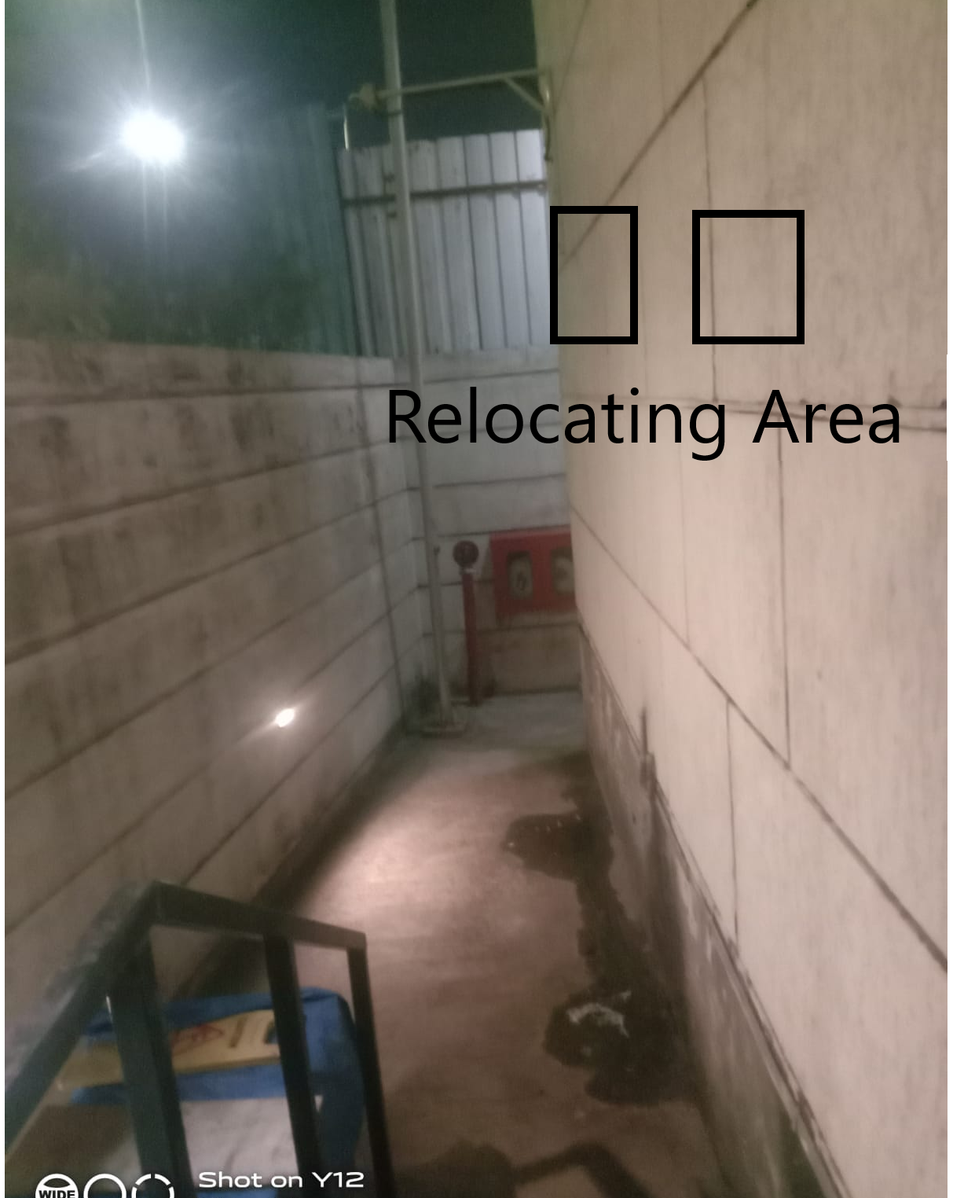 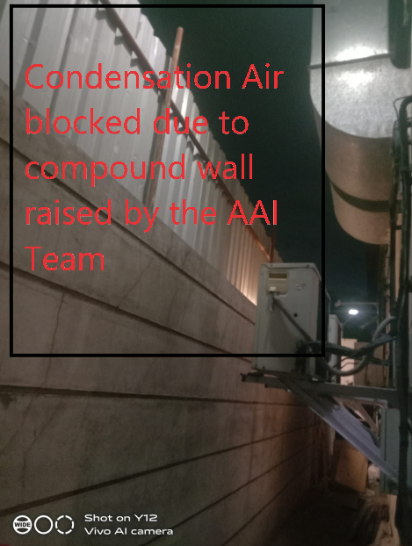

* Walk in freezers temperature not maintained due condensation air flow roaming there only
* Attached quotation from the OEM vendor.