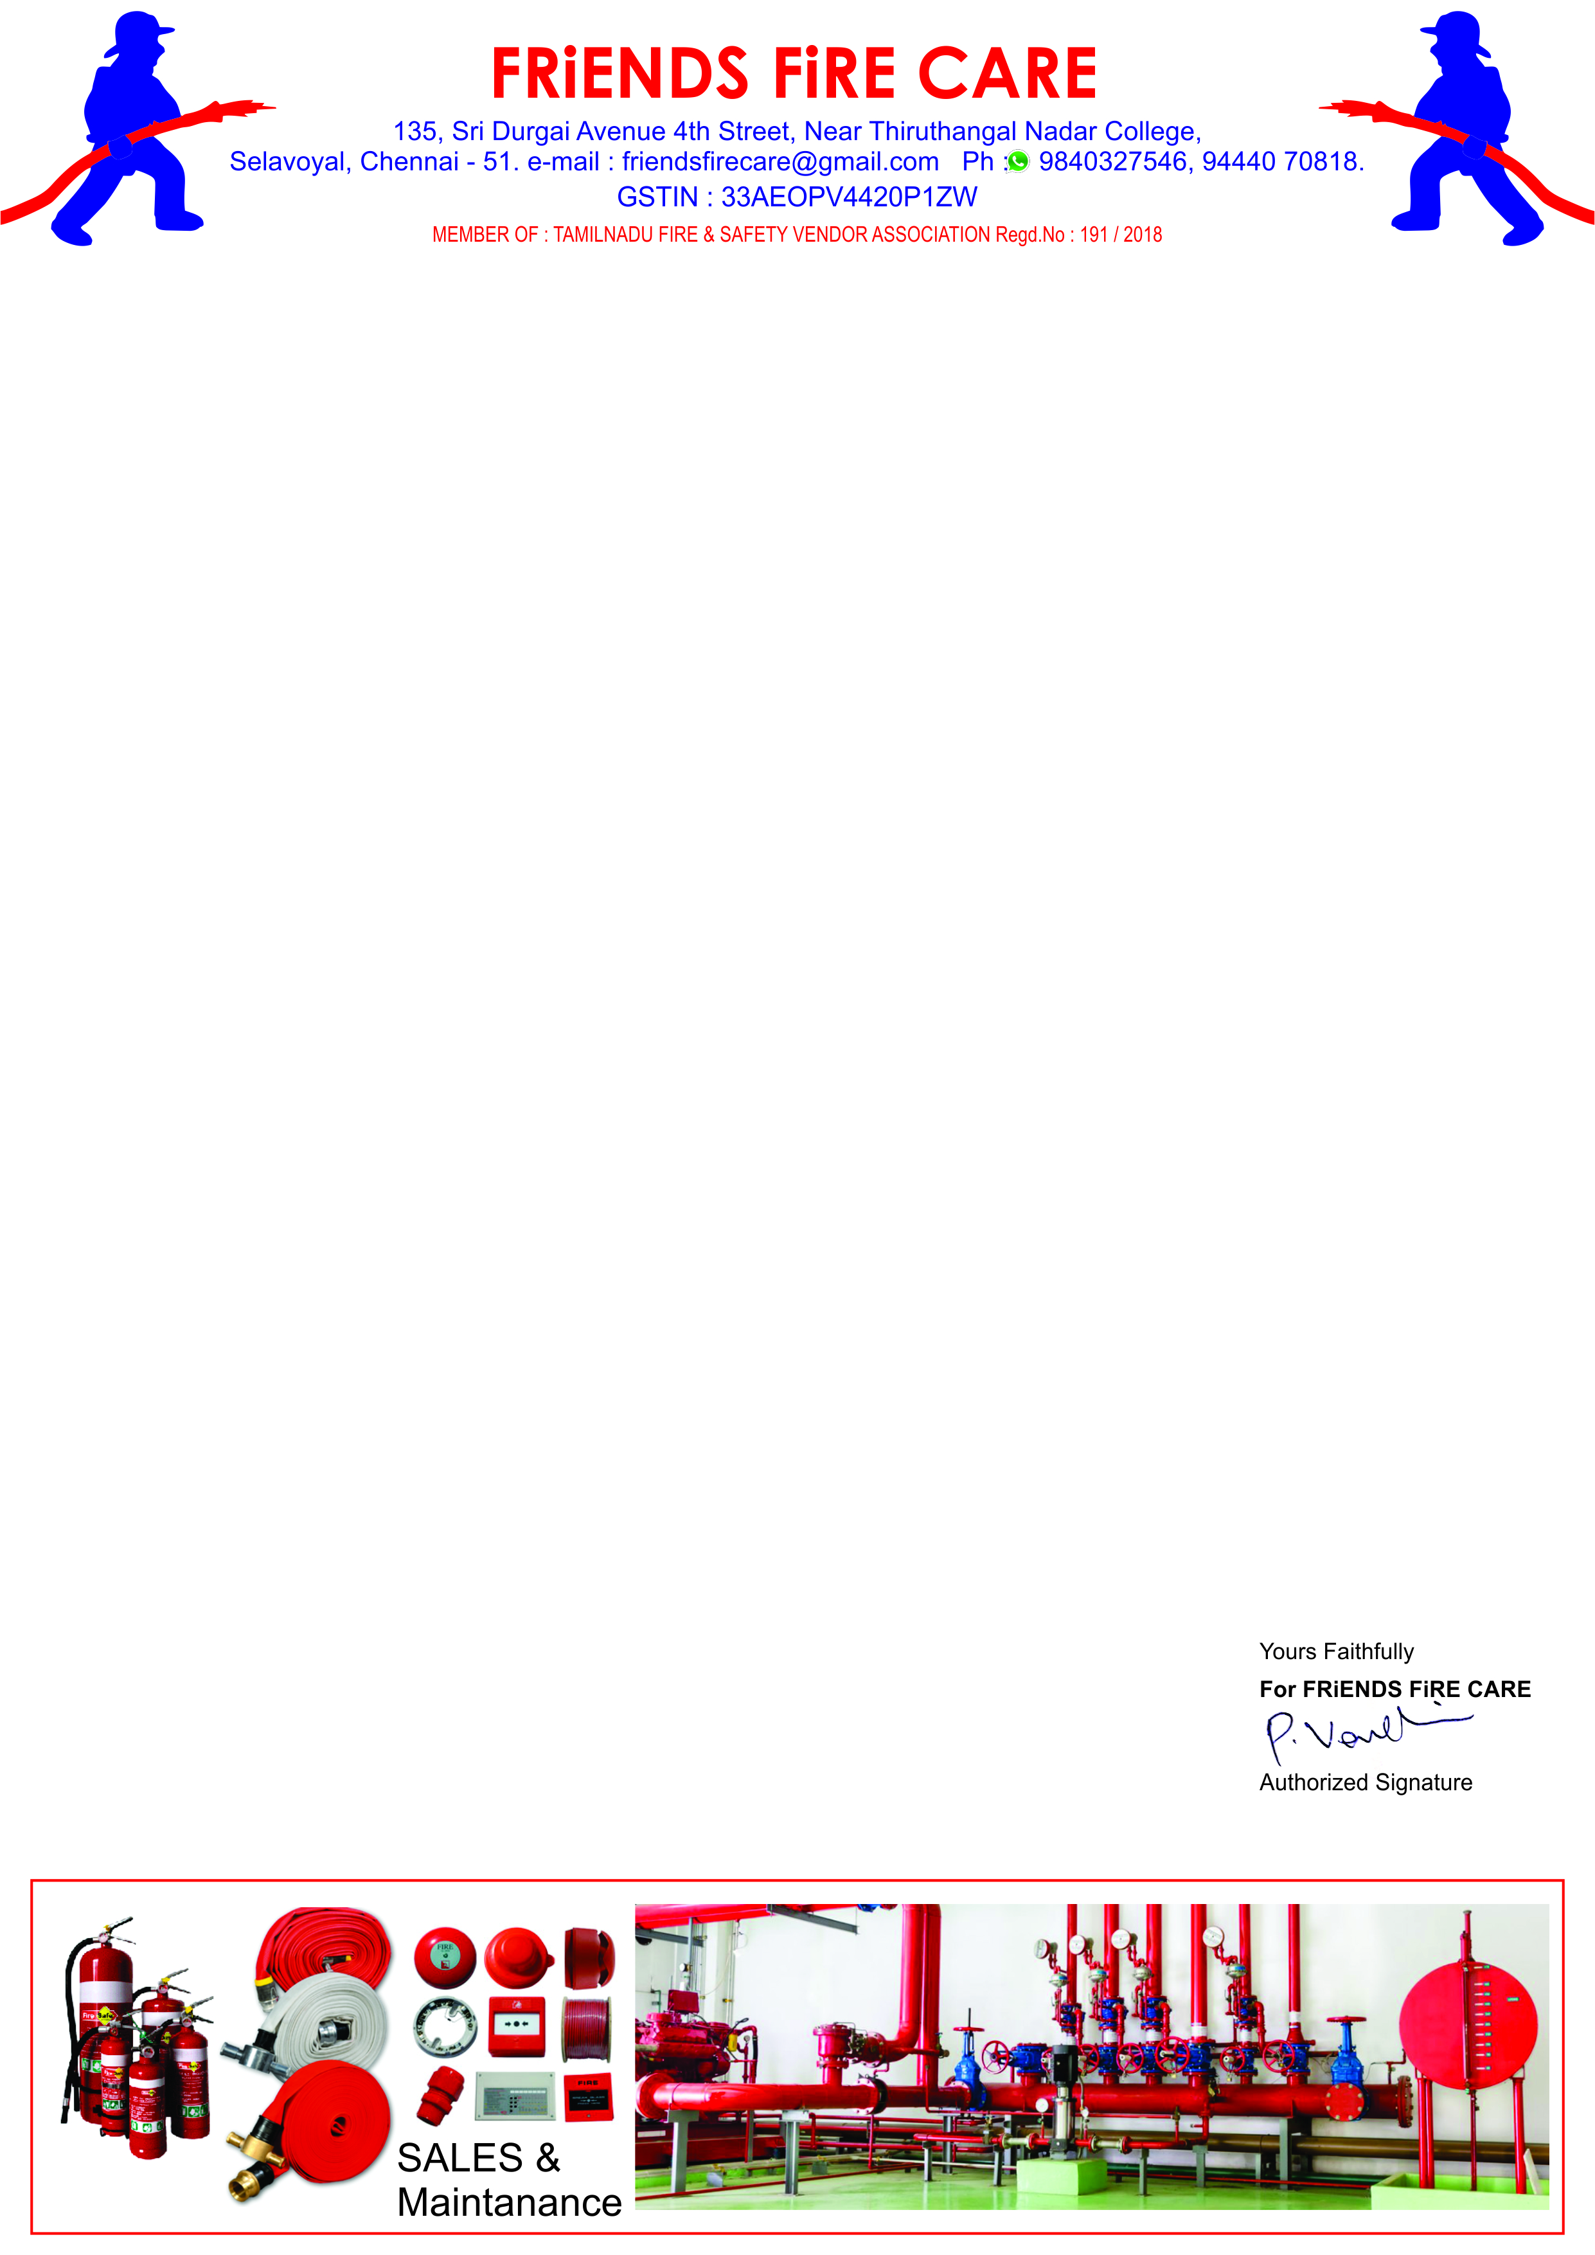

**Ref: FFC/QTN/061/ 24 -25**

**Date: 17.06.2024.**

**To,**

**M/S .Travel Food Services Chennai Pvt. Ltd.,**

**Next to S2 Police Station,**

**Chennai International Airport, Chennai-600027.**

**Dear Sir,**

**SUB: Offer For Fire Extinguisher Spares – Reg.**

**We reference to the above subject of we hereby submit our most competitive offer as under for your kind consideration.**

|  |  |  |  |  |
| --- | --- | --- | --- | --- |
| **S.NO** | **Description** | **Qty** | **Rate** | **Amount** |
| **1.** | **Supply & Fixing of Control Valve For CO2 - 22.5 kg. Ext.** | **01 No.** | **975/-** | **975.00** |
| **2.** | **Supply & Fixing of Control Valve For Foam - 9ltr. Ext.** | **01 No.** | **250/-** | **250.00** |
| **3.** | **Supply of Discharge Hose For ABC Fire Extinguisher.** | **05 No.** | **150/-** | **750.00** |
| **4.** | **Supply of Hose holding clamp For ABC Fire Extinguisher.** | **10 No.** | **50/-** | **500.00** |
| **5.** | **Supply of Bend Pipe with Horn for CO2 - 2 kg. Ext.** | **01 No.** | **150/-** | **150.00** |
| **6.** | **Supply of Discharge Horn for CO2 - 4.5 kg. Extinguisher.** | **03 No.** | **150/-** | **450.00** |
| **7.** | **Supply of Discharge Hose with Horn for CO2 - 4.5 kg. Ext.** | **02 No.** | **350/-** | **700.00** |
| **8.** | **Supply of Body Handle for CO2 - 4.5 kg. Extinguisher.** | **03 No.** | **100/-** | **300.00** |
| **9.** | **Supply of Open Close Wheel For CO2 - 4.5 kg. Extinguisher** | **02 No.** | **100/-** | **200.00** |
|  | **Sub Total** | | | **4,275.00** |
|  | **GST 18 %** | | | **770.00** |
|  | **Grand Total** | | | **5,045.00** |

**General Terms**

1. **Validity : 30 days.**
2. **Price : All inclusive ( Transportation )**
3. **Payment : 100 % Along with work order.**
4. **Delivery : 3 to 5 days.**

**We thank you for your confidence on us and we assure you that we will provide our prompt and best services at all times.**