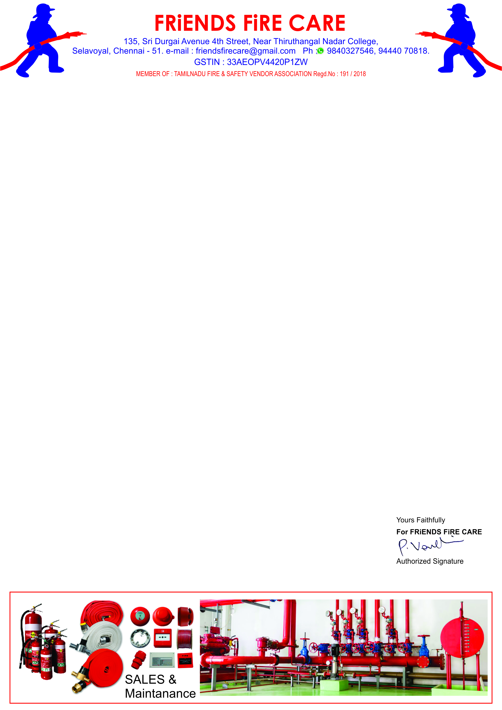

**Ref: FFC/QTN/085/ 24 -25**

**Date: 03.08.2024.**

**To,**

**M/S .Travel Food Services Chennai Pvt. Ltd.,**

**Next to S2 Police Station,**

**Chennai International Airport,**

**Chennai- 600027.**

**Dear Sir,**

**SUB: Offer For Fire Extinguisher Refilling – Reg.**

**We reference to the above subject of we hereby submit our most competitive offer as under for your kind consideration.**

|  |  |  |  |  |
| --- | --- | --- | --- | --- |
| **S.NO** | **Description** | **Qty** | **Rate** | **Amount** |
| **1** | **Refilling Charges for Stored Pressure ‘ K ‘ - Type 6 ltr. Cap. Ext.** | **04 No.** | **2900/-** | **11,600.00** |
|  | **GST 18 %** | | | **2,088.00** |
|  | **Grand Total** | | | **13,688.00** |

**General Terms**

1. **Validity : 30 days.**
2. **Price : All inclusive ( Transportation To & Fro )**
3. **Payment : 100 % Along with work order.**
4. **Work Completion : 5 to 7 days.**
5. **Warranty : 2 Years.**

**We thank you for your confidence on us and we assure you that we will provide our prompt and best services at all times.**