

ASCOM Engineers & Consultants

**Construction Cost Management Company**

Specializing in cost estimating, cost analysis, benefit analysis, contract management, contract administrations (tender documents, comparative statements, finalization of contractors with required technical & commercial documents) contractor negotiations, client representation, claims mitigation and sustainable construction and value engineering services

ASCOM Cost Consultants for Unbiased, Unbridled & Reliable advice

### **COMPANEY PROFILE**

ASCOM, Engineers & Consultants is formed and driven under the guidance of Civil Engineer,S.P.Singh,Quantity Surveyor, Valuer & have vast experience in Quantity Surveying and Management Techniques since 2006. We have a team of Civil & MEP Quantity Surveyors with vast experienced which includes a distinctive mixture of licensed professional Engineers, certified cost engineers, schedulers, trained value specialists, and all with design and construction backgrounds. This creates a team which is unparalleled as a credentialed construction cost management staff.

ASCOM, Engineers & Consultants is a firm promoted by well experienced professionals from leading Architectural/ Engineering/ Consultant firms. All activities are being executed under the guidance of advising/ specialist team on appropriate service of construction activities. Our specialist/ advising team collates up to date knowledge and information on day to day studies. With the vast experience and background specialized skills from our experience, we are well placed to provide all related service of Quantity Survey and Cost Management techniques in Construction Industry.

We can provide the comprehensive range of integrated construction cost management to serve the construction industry. We work extensively with corporate, commercial, industrial, Restaurants, Mobile outlets, institutional, malls/ hotels and residential projects.

We have a team of experienced Engineers & Quantity surveyors in Civil Interior & MEP works including additional services if any of various package contracts of construction techniques.

We provide services at all phases of a project from initial project marketing and planning throughout design and construction. We use the advanced computer software available and have been so successful, repeat clients grow through new clients each year.

We ensure high levels of dedication to the project along with constant day to day monitoring of the project which helps in the fruitful completion of the project. This helps clients to get more flexible Cost Management Services with the help of our network.

PROJECT

**KFC(Sapphire Foods India Pvt Ltd)**

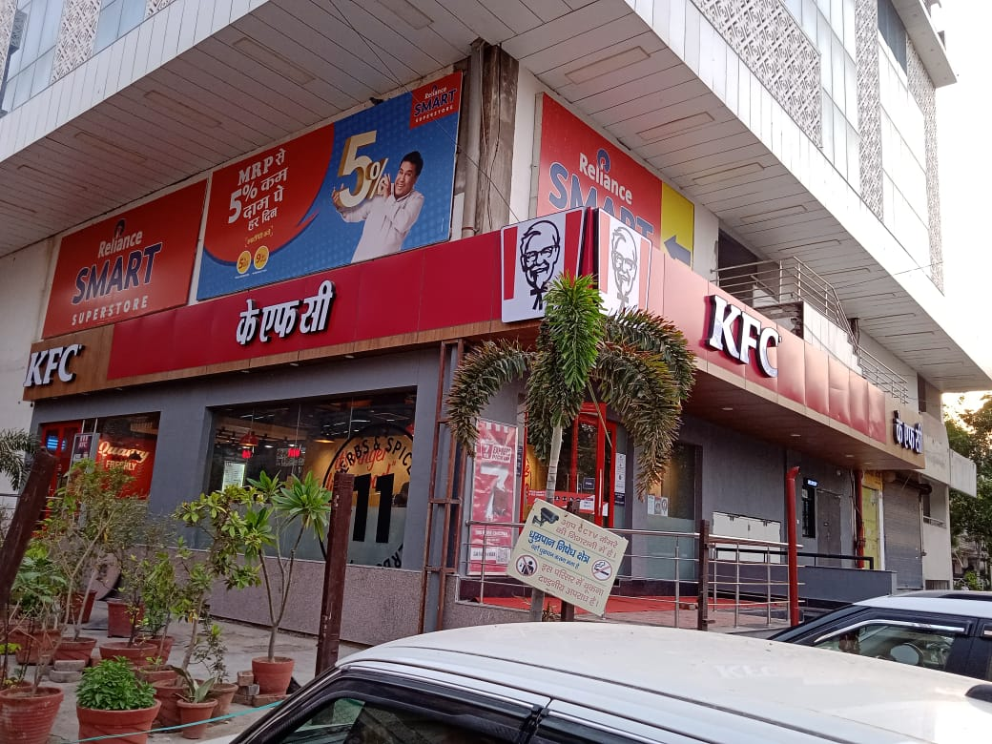

Project Audit of Civil & Interior works, Plumbing, Fire Fighting, RO, MS work, Electrical, HVAC (Low side & High side) works, Extra Items, Rate & Amount verification etc.(Store Audited249+ Stores (KFC &PH)

**PIZZA HUT(Sapphire Foods India Pvt Ltd)**

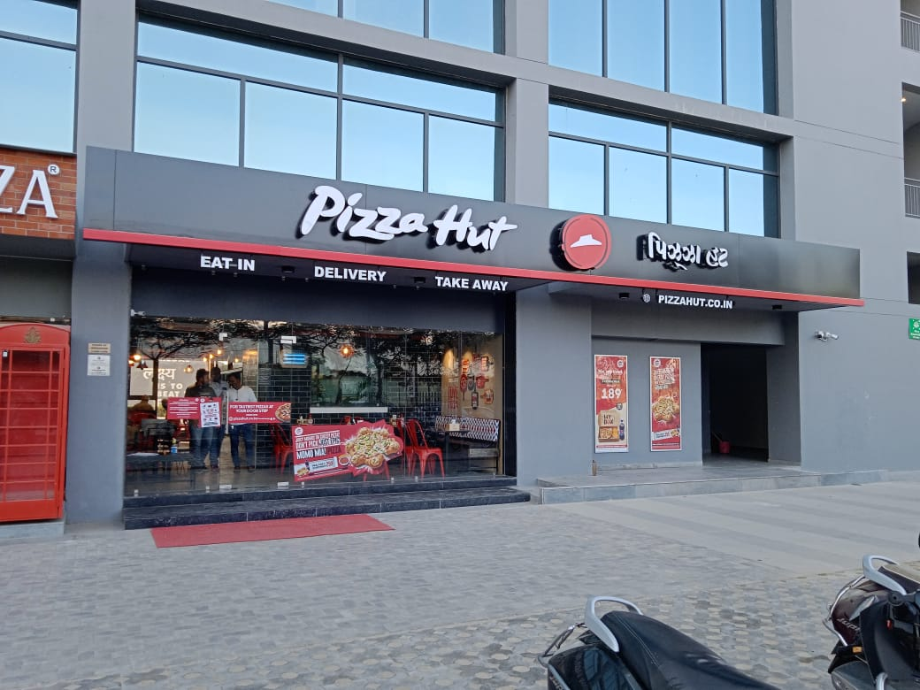

Project Audit of Civil & Interior works, Plumbing, Fire Fighting, RO, MS work, Electrical, HVAC (Low side & High side) works, Extra Items, Rate & Amount verification etc.(Store Audited249+ stores (KFC &PH)

**TACOBELL (Burman Hospitality Pvt Ltd)**

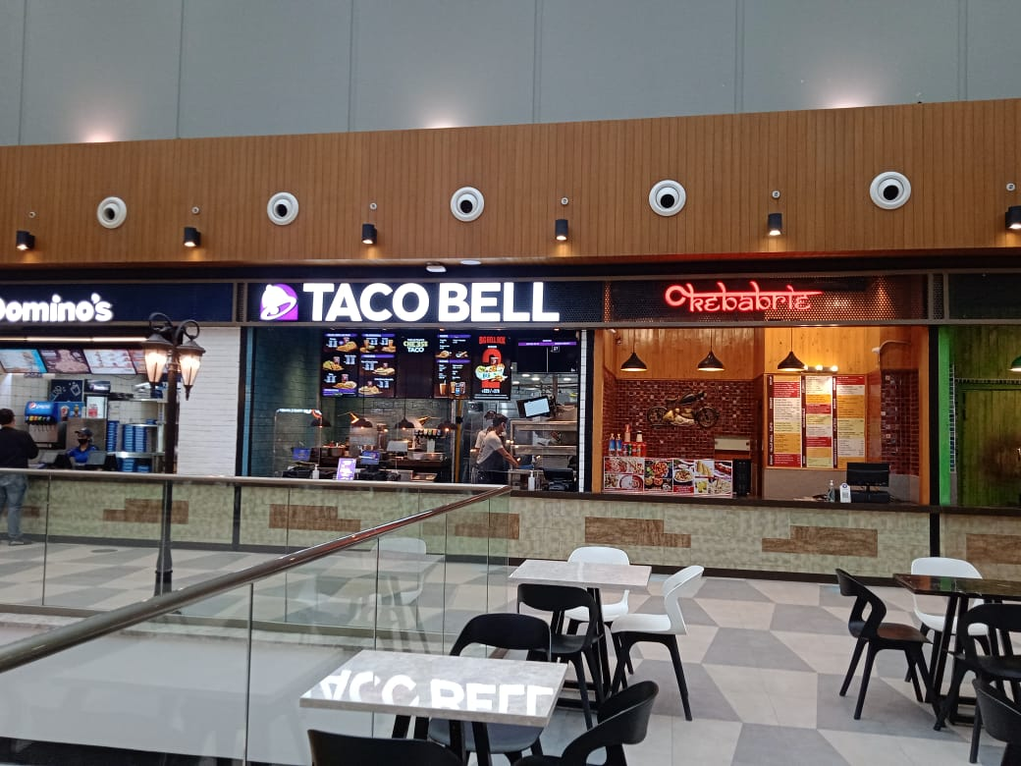

Project Audit of Civil & Interior works, Plumbing, Fire Fighting, RO, Panel, MS work, Electrical, HVAC (Low side & High side) works, Extra Items, Rate & Amount verification etc. (Store Audited 22 + stores )

**ABSOLUTE BARBECUES (Absolute Barbecues Pvt Ltd)**

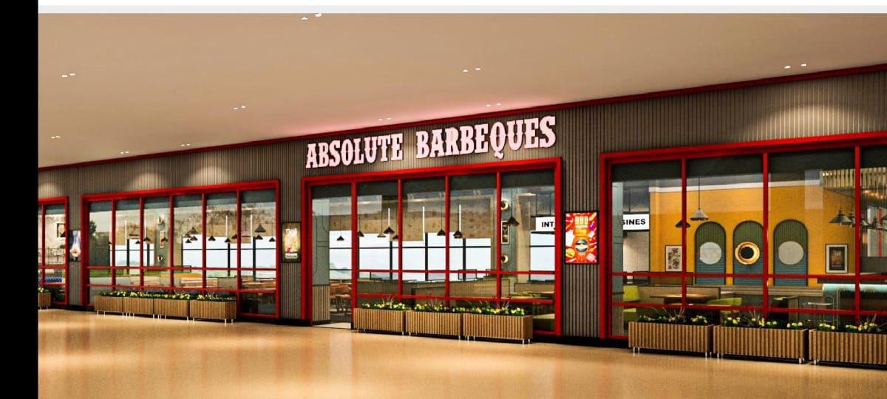

Project Audit of Civil & Interior works, Plumbing, Fire Fighting, RO, Panel, Gas Bank, Signage, MS work, Electrical, HVAC (Low side & High side) works, Extra Items, Rate & Amount verification etc. (Store Audited 02 (6500 Sqft each approx.)

**BURGER KING (Restaurant Brand Asia Ltd)**

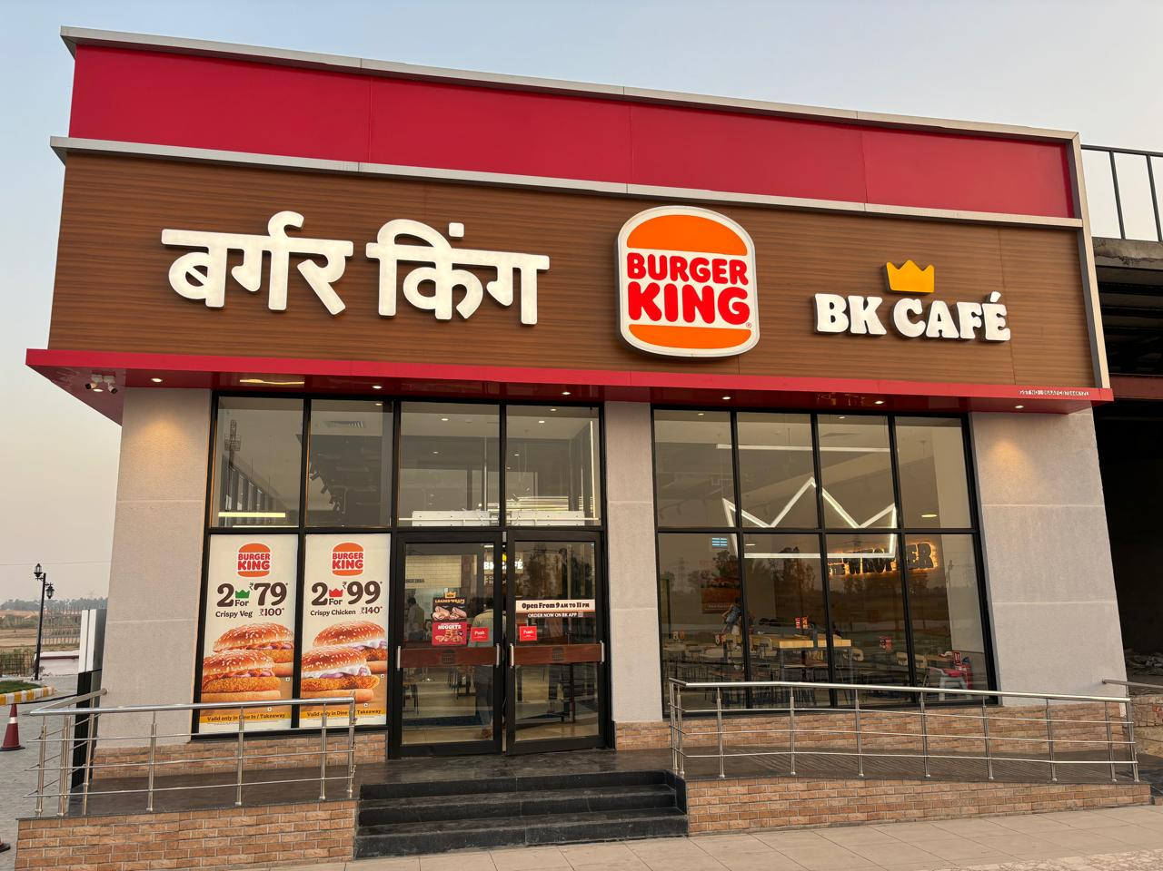

Project Audit of Civil & Interior works, Plumbing, Fire Fighting, RO, Panel, Gas Bank, Signage, MS work, Electrical, HVAC (Low side & High side) works, Extra Items, Rate & Amount verification etc. (09 Store Audited this year (2000-2500 Sft each approx.)

**AWARD / ACHIEVEMENT& RECOGNITION**

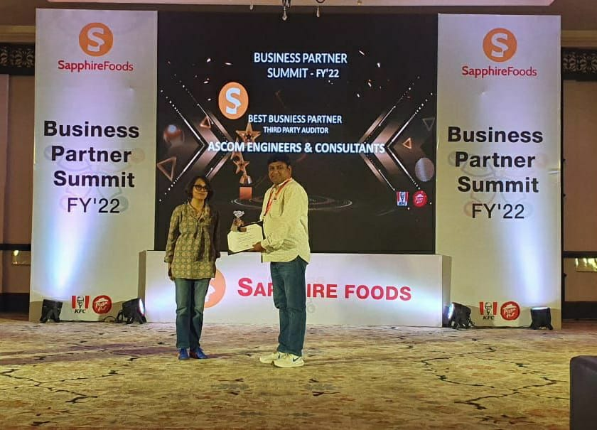

We were awarded for best auditor for FY 21-22 in Sapphire Business Partner Summit FY 22, and saved 2.12 Cr company cost in FY 21-22 in 69 store audits.

**Achieved Amount figures till date in different company: -**

|  |  |  |  |  |  |  |  |  |
| --- | --- | --- | --- | --- | --- | --- | --- | --- |
| **F. Year** | **Company** | **Brand Name** | **No of Stores** | **Total Billed Value by Vendor** | **Total Audited Value by AEC** | **Achived amount** | **Achived amount per store** | **Remarks** |
| 2021-2022 | Sapphire Foods I Pvt Ltd | KFC & PH | 69 | **28,02,55,542.07** | **25,89,82,768.86** | **2,12,72,773.21** | **3,08,301.06** | Jun to Mar |
| 2022-2023 | Sapphire Foods I Pvt Ltd | KFC & PH | 88 | **43,11,70,480.74** | **38,87,77,461.99** | **4,23,93,018.75** | **4,81,738.85** | Apr to Mar |
| Burman Hospitaity Pvt Ltd | TACOBELL | 16 | **6,73,34,034.55** | **5,89,35,566.65** | **83,98,467.90** | **5,24,904.24** | Apr to Mar |
| Absolute Barbecue Pvt Ltd | Absolute Barbecus | 1 | **2,07,40,290.00** | **1,77,09,863.00** | **30,30,427.00** | **30,30,427.00** | Apr to Mar |
| Devyani International Ltd | KFC | 2 |  |  |  |  | Apr to Mar |
| 2023-2024 | Sapphire Foods I Pvt Ltd | KFC & PH | 88 | **37,31,32,797.43** | **33,29,14,828.30** | **4,02,17,969.13** | **4,57,022.38** | Apr to Mar |
| Burman Hospitaity Pvt Ltd | TACOBELL | 6 | **2,99,17,160.49** | **2,66,63,801.97** | **32,53,358.52** | **5,42,226.42** | Apr to Mar |
| Restaurant Brand Asia Pvt Ltd | Burger King | 9 | **5,89,37,460.09** | **5,16,86,507.65** | **72,50,952.44** | **8,05,661.38** | Apr to Mar |
|  |  |  |  |  |  |  |  |  |
|  |  |  |  |  | **TOTAL** | **12,58,16,966.95** |  |  |

**OUR SERVICES: -**

Initial budget costing:

During design proposal to access the feasibility of the project.

Cost advice:

On various alternative design / material/ system proposals.

Detailed Estimate:

For project monitoring and cost planning per design.

Rate Analysis:

For the contract firms to quote their prevailing rates per tender terms.

Value Engineering:

To maximize value for money per design options.

Procurement advice:

For appropriate method of contract package and tender procedures.

Management:

On construction activities and procurement methodology.

Sourcing:

Advice on appropriate management technique for selection of contractor/ vendor.

Post Tender Management:

Includes contract documentation, progressive payment certification, scrutiny of running bills, updating the order amendment.

Contact Us ASCOM ENGINEERS & CONSULTANTS

HEAD. OFFICE: GST NO. 09ANAPP2604G1Z9

A-8, FF, 1/41, Shri Ganesh Building MSME Reg. No. UDYAM-UP-29-0045728

Sector -2, Rajendra Nagar, Sahibabad.

Ghaziabad 201005, India

Phone:+91-9819282820, +91-9818306157

E-mail: [ascom.engineers@gmail.com](mailto:ascom.engineers@gmail.com)

sp.singh@ascomengineers.com