[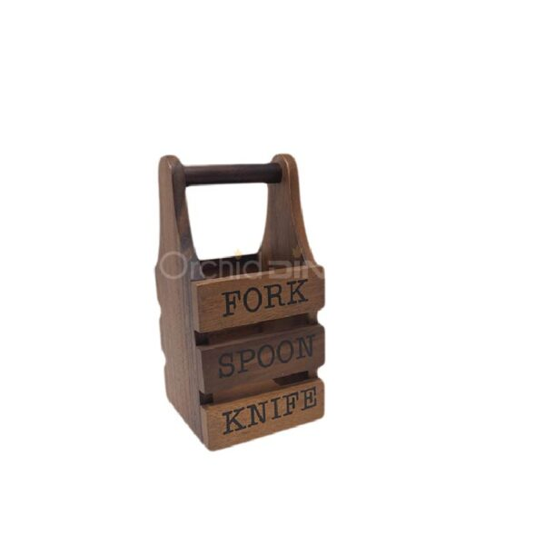](https://orchiddinex.com/product/acacia-utensil-holder/)