[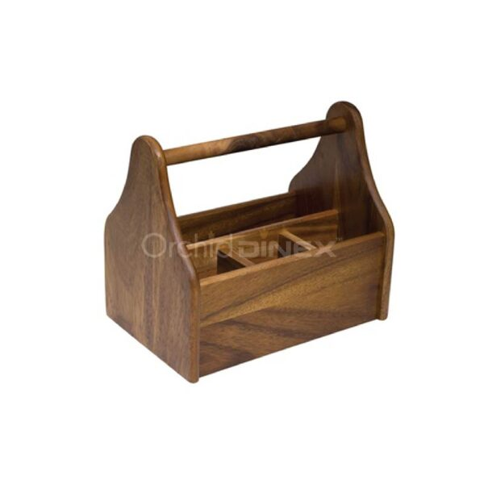](https://orchiddinex.com/product/acacia-cutlery-holder-4-div/)