[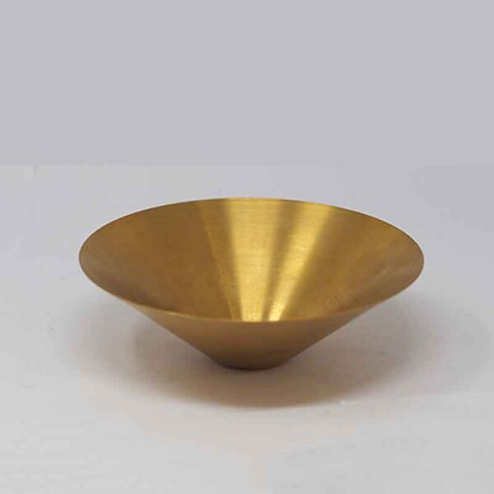](https://orchiddinex.com/product/dinex-ss-golden-salad-bowl-28cm/)