[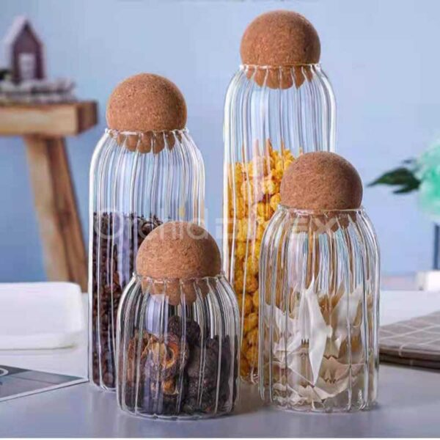](https://orchiddinex.com/product/dinex-glass-jar/)