[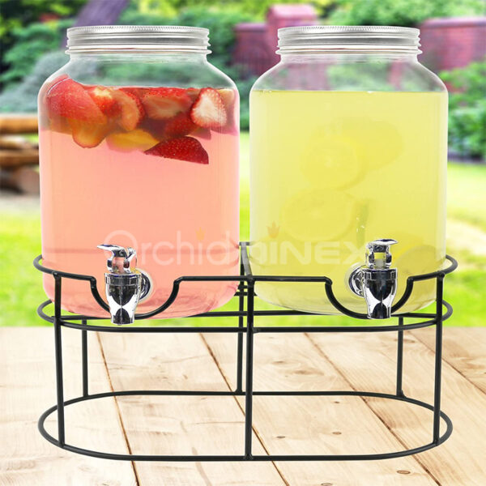](https://orchiddinex.com/product/glass-double-beverage-dispenser-with-metal-stand/)