[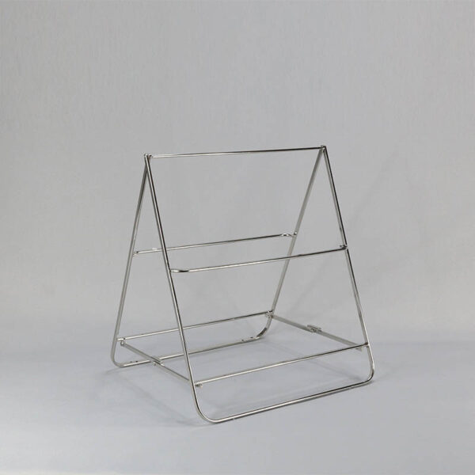](https://orchiddinex.com/product/dinex-14-ss-foldable-stand/)