[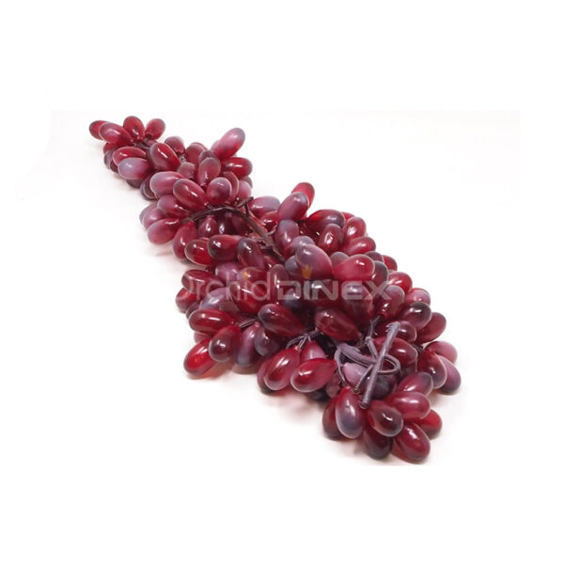](https://orchiddinex.com/product/dinex-artificial-furit-graps/)