[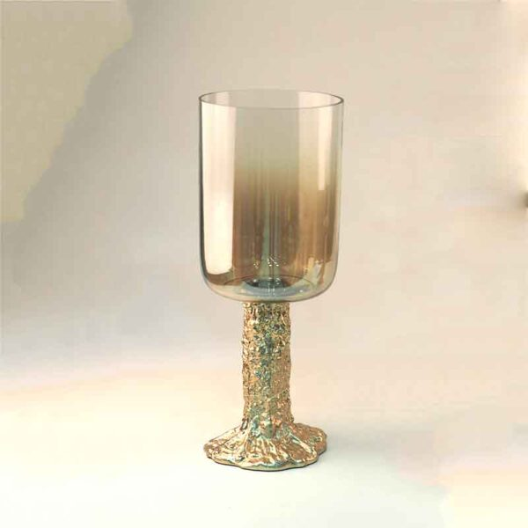](https://orchiddinex.com/product/dinex-candle-holder-gold-finished-aluminum-with-half-smoke-luster-glass/)