[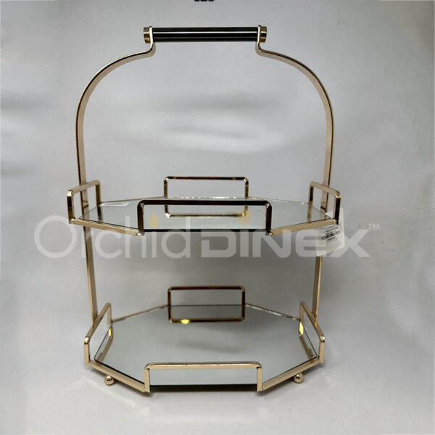](https://orchiddinex.com/product/dinex-charlie-stand/)