[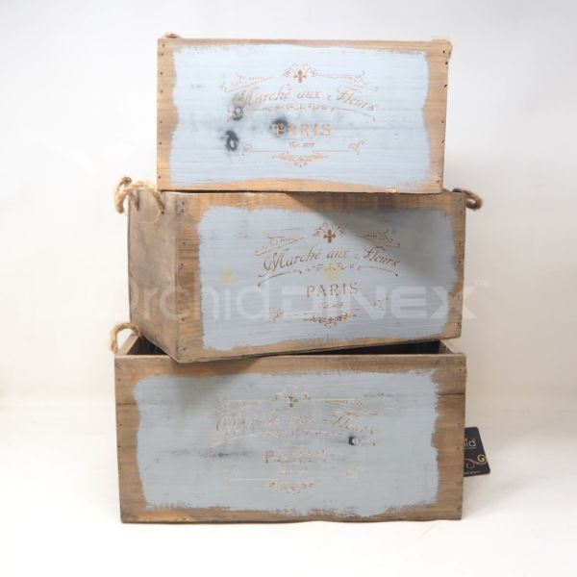](https://orchiddinex.com/product/wooden-suare-box-set-of-3-orchid/)