[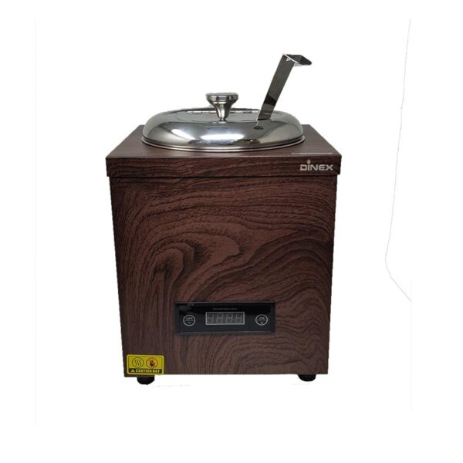](https://orchiddinex.com/product/dinex-electric-soup-warmer/)