[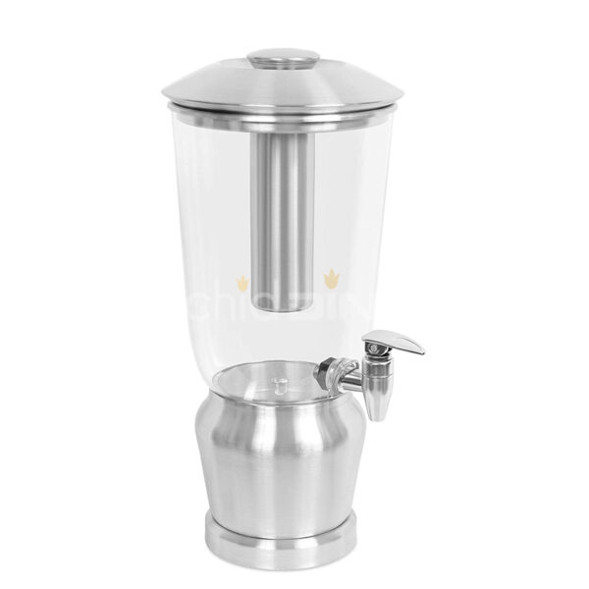](https://orchiddinex.com/product/15l-single-juice-and-panipuri-dispenser-stainless-steel/)