[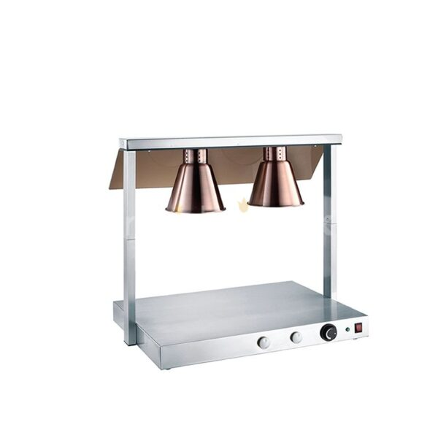](https://orchiddinex.com/product/double-food-warming-station/)