[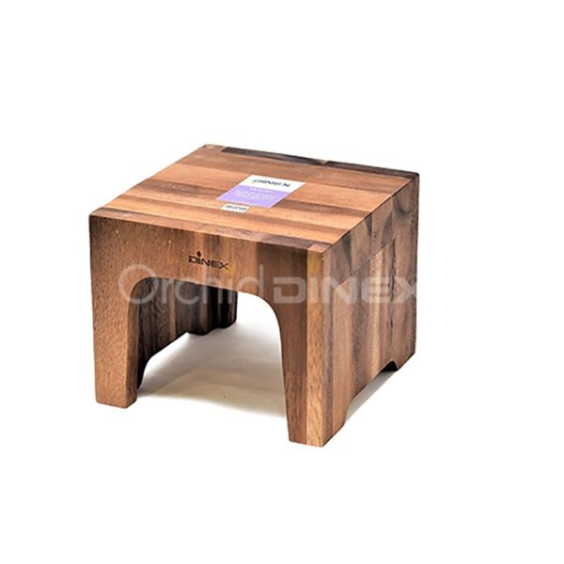](https://orchiddinex.com/product/thick-riser-large/)