[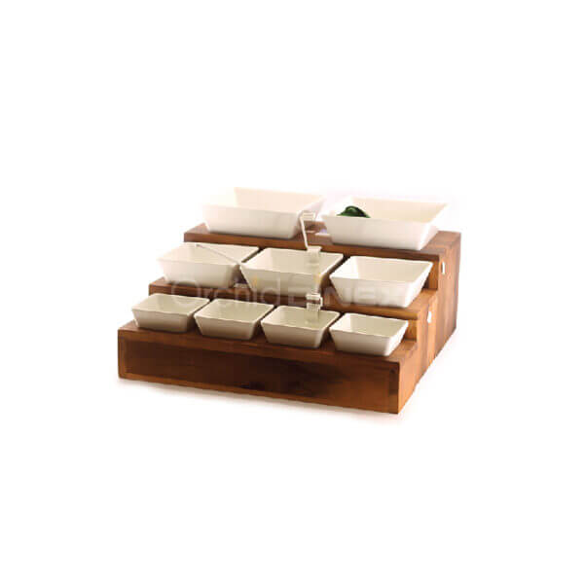](https://orchiddinex.com/product/acacia-wooden-holes-stand-with-5-7-10-sq-bowl/)