[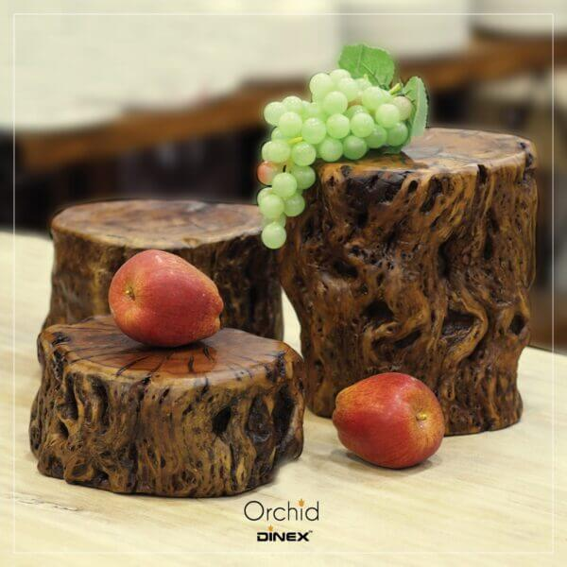](https://orchiddinex.com/product/root-wood-riser-s-m-l/)