[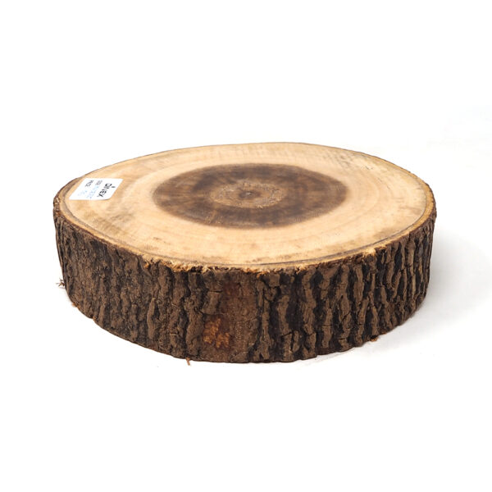](https://orchiddinex.com/product/dinex-acacia-small-wooden-riser-orchid/)