[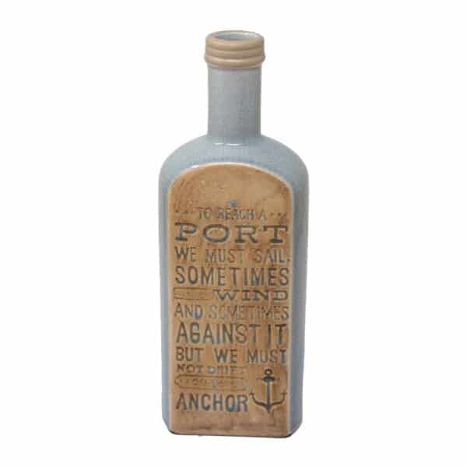](https://orchiddinex.com/product/dinex-ceramic-bottle-vase-orchid/)