[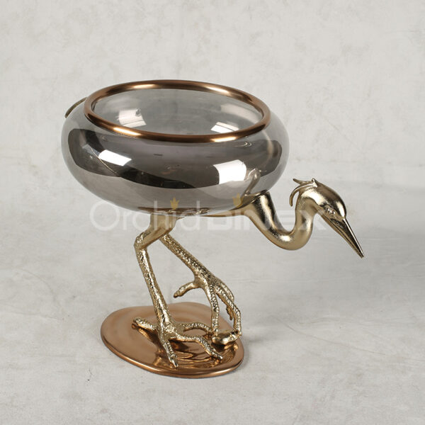](https://orchiddinex.com/product/footed-bowl-large-gold-polished-bronze-finished-aluminum-with-black-chrome-glass/)