[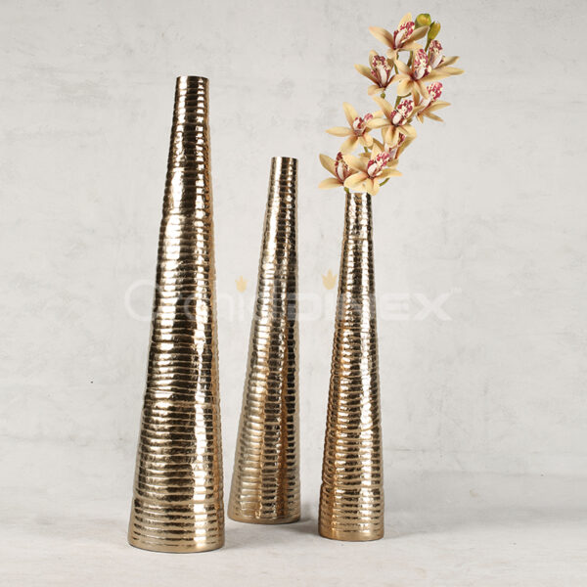](https://orchiddinex.com/product/alu-organic-stripes-slim-tall-vase-m/)