[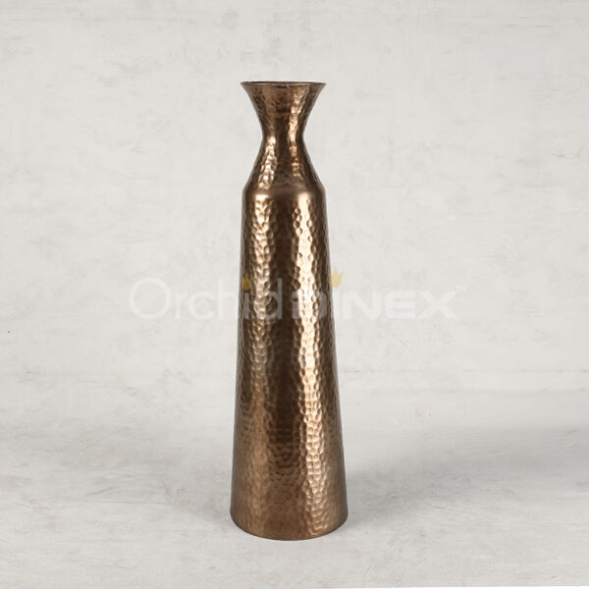](https://orchiddinex.com/product/alu-sparkle-hammer-taper-neck-vase-xl-2/)