[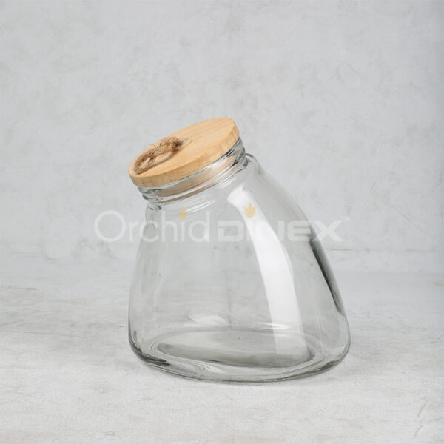](https://orchiddinex.com/product/glass-storage-jar-19/)