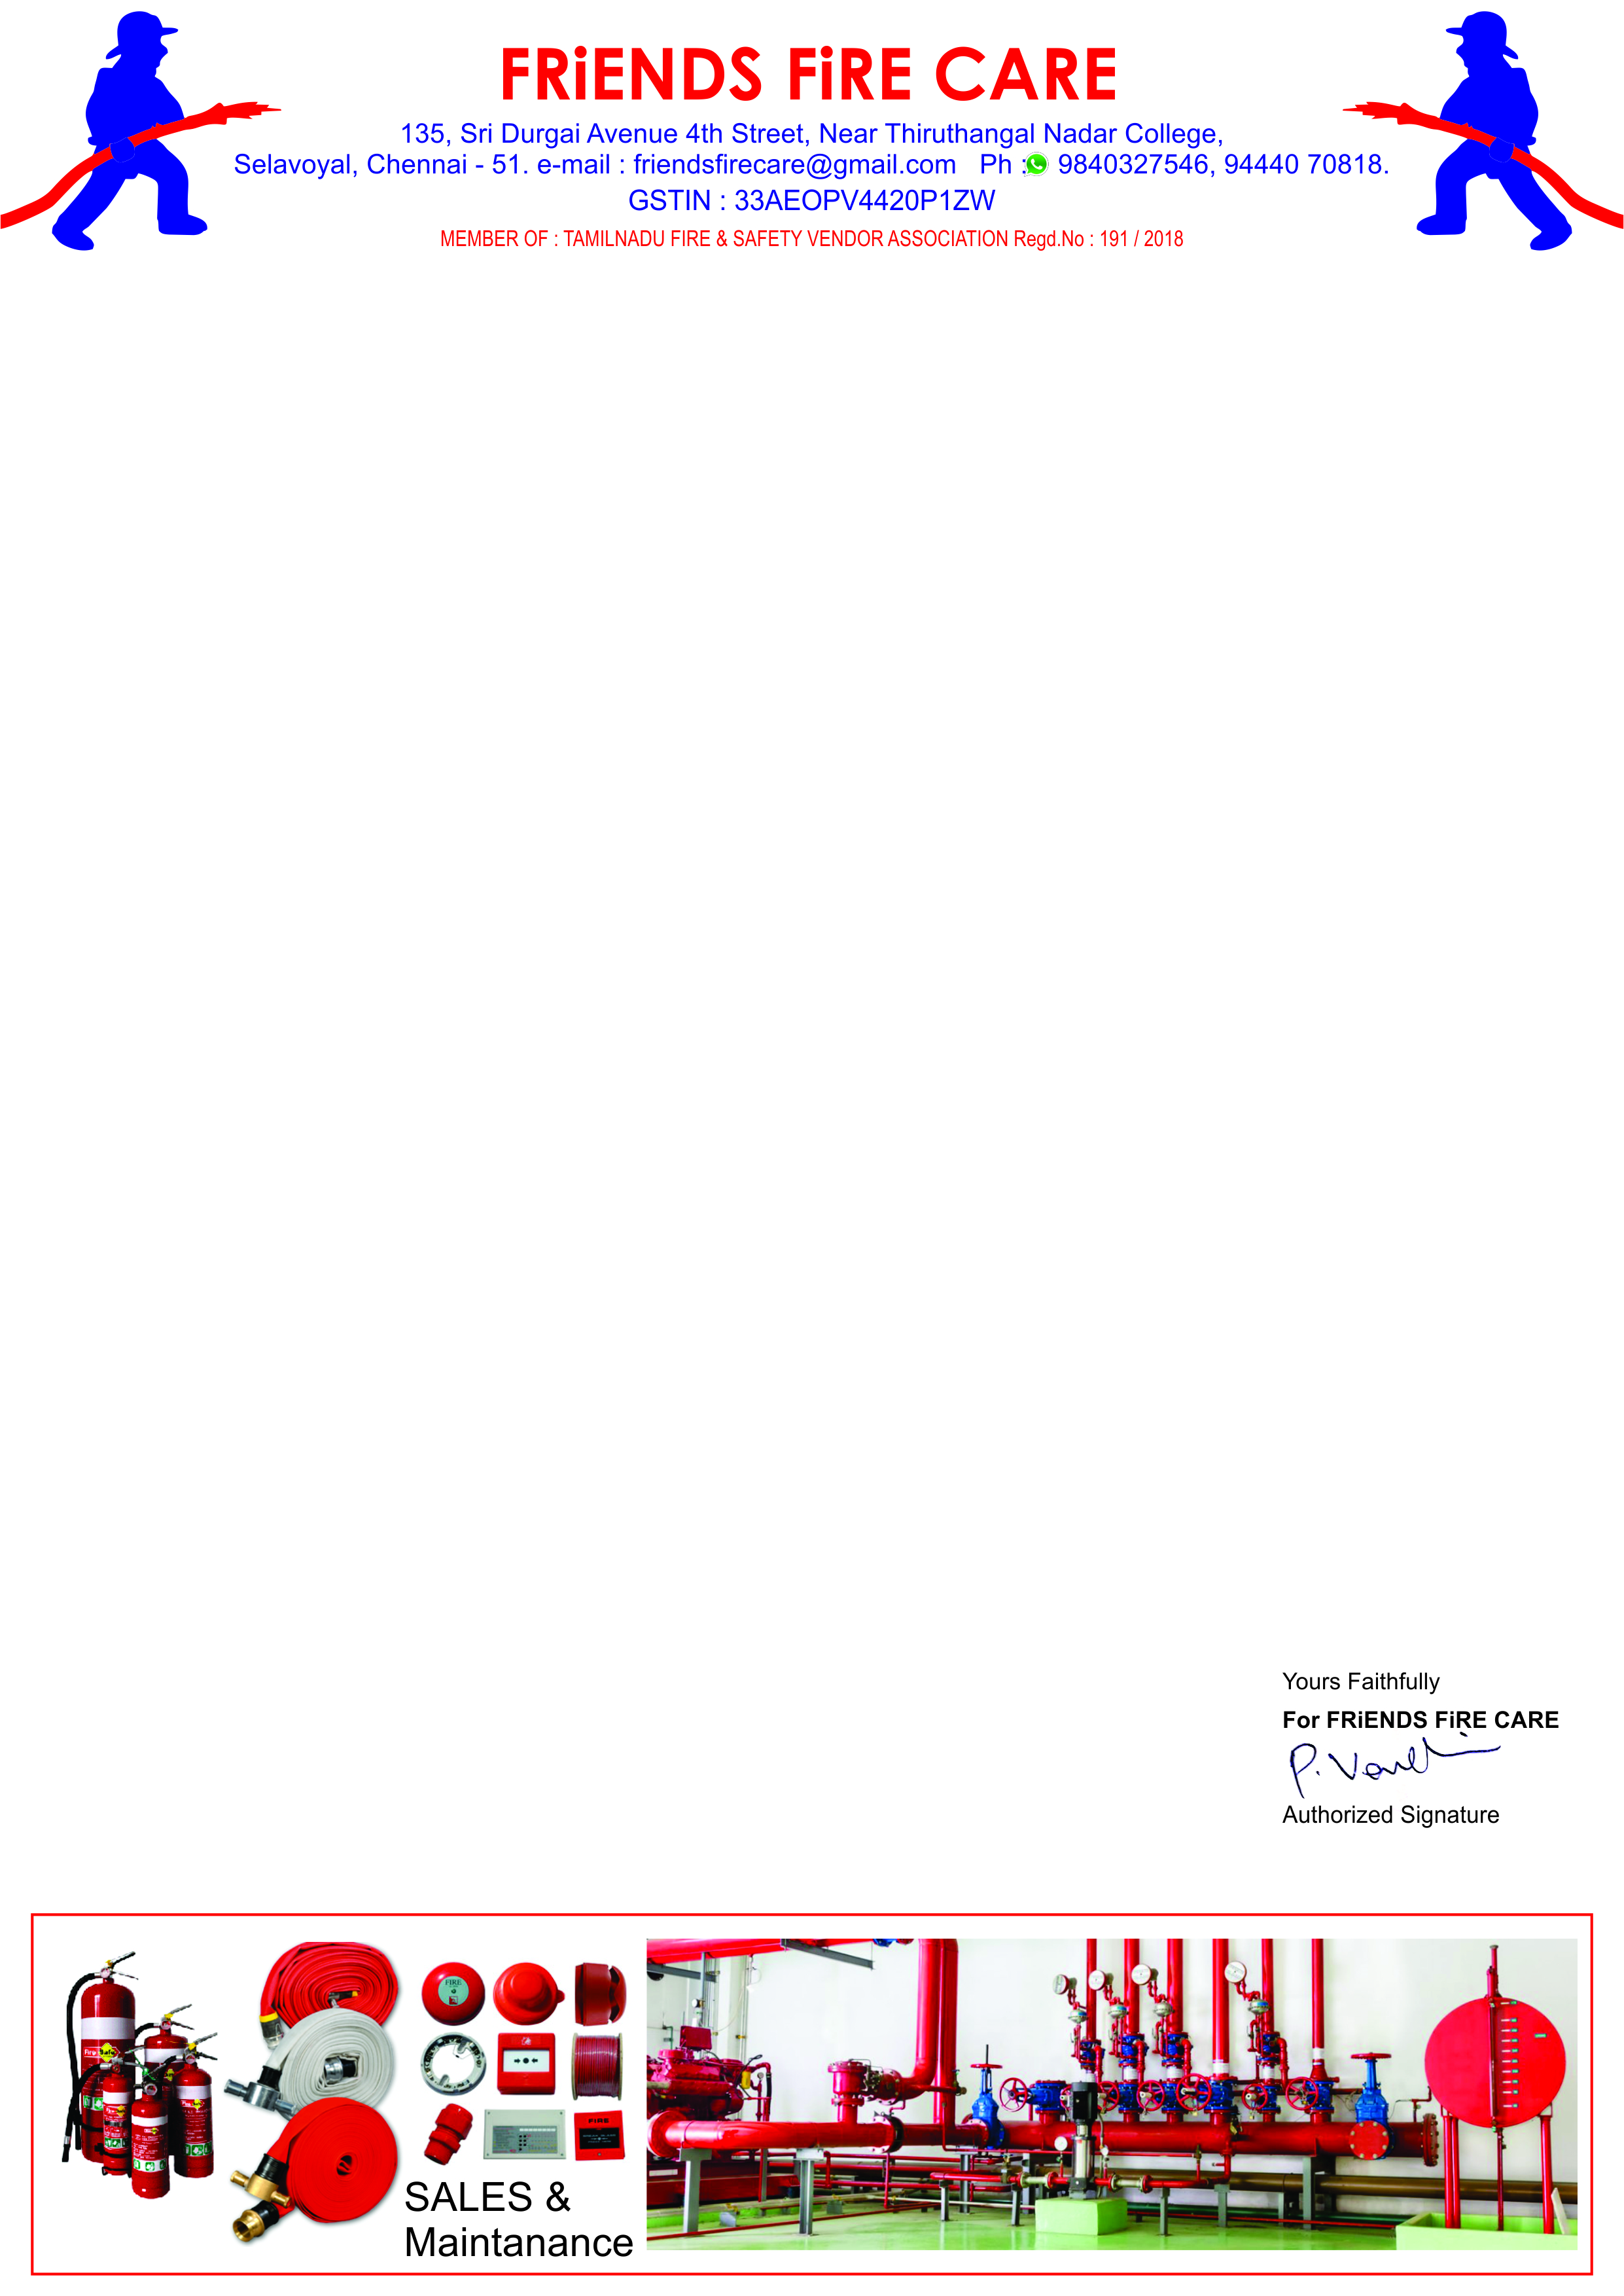

**Ref: FFC/ Qtn./262/23-24 Date: 01.03.2024.**

**To,**

**M/S .Travel Food Services Chennai Pvt. Ltd.,**

**Next to S2 Police Station,**

**Chennai International Airport,**

**Chennai-600 027.**

**Dear Sir,**

**Sub: Offer for Fire Extinguisher & Floor Stand -Reg.**

**We reference to the above subject of we hereby submit our most competitive offer as under for your kind consideration.**

|  |  |  |  |  |
| --- | --- | --- | --- | --- |
| **S.No.** | **Particulars** | **Qty.** | **Rate** | **Amount** |
| **1** | **Supply of ABC - 6 kg Capacity Fire Extinguisher Wall Mounting Type HSN- 8424**  **CE Approved Extinguisher.** | **02 No.** | **2000/-** | **4,000.00** |
| **2** | **Supply of CO2 - 4.5 kg capacity Fire Extinguisher Wall Mounting Type. HSN- 8424**  **CE Approved Extinguisher.** | **06 No.** | **4500/-** | **27,000.00** |
| **3** | **Supply of SS Floor Stand For Fire Extinguishers.** | **08 No.** | **490/-** | **3,920.00** |
|  | **Sub Total** | | | **34,920.00** |
|  | **GST 18 %** | | | **6,286.00** |
|  | **Grand Total** | | | **41,206.00** |

**General Terms**

1. **Price : All Inclusive.**
2. **Payment : Along with PO.**
3. **Delivery : 3 Days At Chennai Branch.**
4. **Warranty : 3 Years.**

**We thank you for your confidence on us and we assure you that we will provide our prompt and best services at all times.**